SENIOR FIVE TERM 1

TOPIC 1/2: Introduction to Economics

Definitions of economics

Economics i s concerned allocation of scarce resources to satisfy human endless needs. It deals with the ways in which production, distribution and consumption of goods and services change over time to satisfy human needs.

Key areas of study
Microeconomics: Focuses on the behavior of individual economic units like households, firms, and industries, and how they interact in markets.
Macroeconomics: Analyzes the economy as a whole, looking at broad issues such as inflation, unemployment, economic growth, and monetary and fiscal policy.

Core concepts
- Scarcity: The fundamental economic problem of having seemingly unlimited human wants in a world of limited resources.
- Incentives: How people and firms respond to rewards and penalties, and how these responses drive economic behavior.
- Resource allocation: The study of how limited resources are distributed among competing uses to satisfy wants and needs.

Skills developed
- Analytical and problem-solving skills: Economics develops the ability to use logic and data to solve complex problems.
- Mathematical and statistical skills: The field often requires a strong foundation in mathematics and statistics to build and test models.
- Critical thinking: Students learn to analyze trends, interpret data, and understand the ripple effects of choices and events.

Applications
- Business: Understanding market dynamics, firm behavior, and strategic decision-making.
- Government and policy: Advising on public policy, taxation, and the regulation of markets.
- Finance: Analyzing financial markets, investments, and economic forecasting.
- Other fields: The skills learned are transferable to many areas, including behavioral science, psychology, and international relations.

Reasons for studying economic

1. Understanding the world
- Economics helps us to understand how society allocates scarce resources, which helps us analyze complex issues like poverty, inflation, and government policies.
- Economics provides tools to understand and address major challenges like climate change, inequality, unemployment and geopolitical tensions.
- It helps make sense of how markets work, how companies operate, and how individual and government decisions impact everyday life.
- It offers insights into international trade, cultural interactions, and the economic relationships between different societies.
- It helps students appreciate t h e role of planning both for the present and future generations.

2. Developing valuable skills
- Enhance critical thinking: It trains you to question information, analyze statistics, identify potential biases, and understand the incentives behind human behavior.
- Improve problem-solving: Economics is fundamentally about solving problems, which leads to skills that are highly valued in any profession.
- Build analytical and research skills: It strengthens your ability to research and analyze data, a skill useful in many different fields.

3. Expanding career opportunities
- Diverse job market: An economics degree opens doors to a vast number of careers in fields such as accounting, banking, consulting, finance, and government.
- Preparation for further study: It serves as a strong foundation for graduate programs in economics, business, and law.
- Adaptability: The skills gained are flexible and transferable, preparing graduates to adapt to and succeed in an ever-changing job market.

Positive and Normative economics
Positive Economics: This branch of economics deals with what is. It involves the analysis of facts and cause-and effect relationship in economy.
Positive economics aims to describe and explain economic phenomena based on empirical data and observable facts. For example, a statement like "An increase in the minimum wage leads to higher unemployment among teenagers" is a positive economic statement because it can be tested and verified through data.
Normative Economics: In contrast, normative economics addresses what ought to be. It involves value judgments and opinions about economic policies and outcomes.
Normative statements are prescriptive and cannot be tested or proven true or false. An example would be "The government should increase the minimum wage to reduce poverty," which reflects a belief about what should happen based on ethical considerations.

Key Differences
- Nature of Statements:
  - Positive economics makes testable statements based on facts and data.
  - Normative economics involves value-based statements that reflect opinions or beliefs.
- Objective vs. Subjective:
  - Positive economics is objective and focuses on factual analysis.
  - Normative economics is subjective and incorporates personal or societal values.
Examples:
Positive:
- "The inflation rate is currently 3%."
- "Increasing the minimum wage has led to a decrease in low-skilled jobs" Normative:
- "The inflation rate should be kept below 2% to ensure economic stability.". - "The government should raise the minimum wage"
- "Inflation is too high and the government should take steps to lower it"

Importance in Economics
Understanding the distinction between positive and normative economics is crucial for effective economic analysis and policy-Making
Positive economics provides the foundation for understanding how the economy operates, while normative economics guides decisions about what policies should be implemented based on societal values and goals. Both branches are complementary and necessary for a comprehensive understanding of economic issues.

Wealth refers to the stock of assets and other resources existing in an economy at a given time that can be measured in terms of either real goods or money value and can are used to generate more income.

Characteristic of Wealth
1 It is relatively scarce. That is, it is limited in supply,
- It provides satisfaction (utility)
- It has money value. That is, it has price.
- Wealth can be used to produce more wealth.
- The ownership of wealth is transferable, That is, it can be exchanged.

Broader view of wealth
Holistic framework: The concept of wealth can be expanded beyond material possessions to include a more holistic view that includes natural resources, social capital, and human capital (the value of skills and knowledge).
Societal role: The "wealth economy" framework considers how the use and control of these various forms of capital can lead to prosperity and how they are interconnected.

An economic want is a desire for goods and services that requires money and scarce resources to satisfy. These wants are distinct from non-economic wants, which can be fulfilled without monetary cost, like sunshine or love.
Examples of economic wants include food, cars, and education, and they are often classified as necessities, comforts, or luxuries.

Characteristics of economic wants
- Desire for goods and services: These are things people want to buy or consume.
- Requires monetary value: To satisfy an economic want, money is typically needed to purchase the good or service.
- Uses scarce resources: Since resources are limited, people cannot satisfy all their economic wants and must make choices.
- They are recurrent (endless)
- They are competitive in nature
- They are dynamic, that is, they keep on changing from time to time
- They are complementary, that is, they are jointly used for example car and fuel.
- Can be categorized: Economic wants can be further broken down into different types based on their importance: o Necessities: Essential for survival and basic efficiency, like food, clothing, and shelter.
  - Comforts: Things that make life easier or more enjoyable after basic needs are met, such as air conditioning or a high-quality mattress.
  - Luxuries: Items that provide enjoyment and are sought after based on a person's standard of living, such as designer clothing or a luxury car.
Examples o Basic food is a necessity, but gourmet meals or specialty coffee are considered wants. o Basic, protective footwear is a need, while stylish or branded sneakers are wants.
  - A mobile phone is a want for communication and convenience, which has become more of a necessity over time.

The fundamental economic questions
The economic questions influence resource allocation. They include;
- What to produce? This question deals with which goods and services society will create. That is, the nature of the commodity to be produced. Whether capital or consumer goods, for export or for domestic consumption etc.
- How to produce? This question concerns the methods and resources used for production. Should production rely heavily on human labor, advanced machinery, or a combination of both?
- For whom to produce? This question addresses the distribution of the goods and services that are produced. That is, the nature of consumers who are to consume the products.
- When to produce? Addresses the time of production; that is, the period or season of production, whether to produce now or in future.
- Where to produce from? Address the place; that is, the location of the business, whether to produce near the source of the raw materials or near the market

Categories of Goods

(i) Based on production and use
- Consumer Goods: Products bought by individuals for personal use and satisfaction,
such as food, clothing, and electronics.
- Capital Goods: Goods used by businesses to produce other goods and services, like machinery and raw materials.
- Intermediate Goods: Goods used as an input in the production of other goods, such as steel used to make cars.
- Final Goods: Goods that are ready for consumption or use, which have already been accounted for as either consumer or capital goods.

(ii) Based on monetary value
- Free goods: these are goods which exist naturally in abundance such that one’s desire can be satisfied at zero prices. For example, water, sunshine, air, etc.
- Economic goods these are goods which are relatively scarce as compared to human wants and their consumption involves a cost.

(iii) Based on rivalry and excludability
- Private Goods: Goods that are both rivalrous (one person's consumption prevents another's) and excludable (it's possible to prevent non-payers from consuming them).
- Public Goods: Goods that is non-rivalrous and non-excludable, such as national defense or clean air.
- Common Resources: Goods that is rivalrous but non-excludable, like fish in the ocean.
- Club Goods: Goods that are non-rivalrous but excludable, such as cable TV or private parks.

(iv) Based on income and price elasticity
- Normal Goods: Demand increases as consumer income increases.
- Inferior Goods: Demand decreases as consumer income increases; they are often replaced by more desirable alternatives as income rises.
- Luxury Goods: Demand increases disproportionately as income rises.
- Giffen Goods: A rare type of inferior good where demand increases as the price rises, violating the law of demand.

(v) Based on relationship to other goods
- Substitute Goods: Goods that can be used in place of each other (e.g., butter and margarine).
- Complementary Goods: Goods that are consumed together (e.g., coffee and sugar).

(vi) Based on social value
- Merit Goods: Goods that are considered beneficial for society, which governments may encourage consumption of (e.g., education).
- Demerit Goods: Goods that are considered harmful to society, which governments may discourage consumption of (e.g., tobacco).
(vii) Services; these are intangible items used to facilitate the production of goods and services. For example banking services, transport services, services of a teacher.

Characteristics (Features) of economic goods
- Scarcity: The supply of economic goods is limited relative to the demand for them. This scarcity creates the need for choices and trade-offs in an economy.
- Utility: They provide satisfaction or usefulness to consumers, which is a key driver of their value.
- Transferability: Economic goods can be exchanged or transferred from one person to another, enabling trade and specialization.
- Monetary Value/Price: They have a price or monetary value because they are not freely available and are the result of human effort or resources.
- Requires Human Effort: The production of economic goods involves labor, capital, and other resources, distinguishing them from "free goods" that exist in unlimited supply.
- Excludability: The ability to prevent someone who has not paid for a good from using it.
For example, a car is excludable because you must pay for it to own and use it.
- Rivalry: The characteristic where one person's consumption of a good reduces its availability for others. For example, the consumption of a single slice of pizza is rivalrous.

Characteristics (Features) of public goods

- They are non-divisible, that is, they are equally available to all individuals in society
- Non-excludability: that is, once a public good is provided, it is difficult or impossible to prevent individuals from benefiting from it. For example, everyone in a city can benefit from streetlights, regardless of whether they pay taxes that fund them.
- Non-rivalry i.e.,The consumption of a public good by one person does not diminish the amount available for others to consume.
- Simultaneous use: The good can be used by multiple people at the same time without its quality or availability being affected. For example: One person listening to a public radio broadcast does not prevent others from listening to the same broadcast.
- Their consumption does not involve a direct cost.
- Often government-provided: Because of the free-rider problem, these goods are typically provided or funded by the government through taxation. For examples, national security and law enforcement.
- Large-scale provision: Public goods are often provided on a large scale, benefiting a wide range of consumers.

Basic (fundamental) economic problems (principles)
There are three fundamental economic problems (principles). These include scarcity, choice and opportunity cost
- Scarcity. This arises because human wants are unlimited but the resources available to satisfy those wants are limited. Due to scarcity, every society must make choices about how to allocate its resources to meet some of the wants.
- Choice is the act of selecting one option from many alternatives, driven by the fundamental concept of scarcity, where limited resources must be allocated to satisfy unlimited wants. Because not all desires can be fulfilled, individuals, businesses, and governments must make trade-offs, leading to the concept of opportunity cost.
- Opportunity (Real) cost; this refers to the value of the second best alternative foregone when choice is made basing the available scarce resources. For example if an individual has 100,000/= and she wants to buy two commodities X and Y whereby the price for X is 100,000/= and the price Y is 150,000/=. If he buys commodity X using all his money, she foregoes the value of commodity Y which is worth 150,000/=

Some uses (importance/applications) of the concept of opportunity cost
In general, Opportunity cost is used to make better decisions by comparing the value of the chosen option against the value of the next-best alternative.
Specific examples include:

Personal life
- Time management: Deciding between different activities, like spending an hour studying versus working a part-time job, involves the opportunity cost of the forgone wages.
- Consumer choices: Choosing to spend money on a vacation means those funds cannot be used for other purchases or investments.
- Career choice: Pursuing further education can have the opportunity cost of lost income during the period of study.

Business
- Resource allocation: Businesses use opportunity cost to decide how to best use limited resources like capital and labor on different projects or tasks. For example, allocating senior accountants to routine work means they are unavailable for strategic analysis, and the opportunity cost is the value of that delayed strategic work.
- Investment decisions: When evaluating two projects, a company considers the potential return of the chosen project against the potential return of the one it had to forgo.
- Production: A factory might decide to produce cars or trucks. The opportunity cost of producing one more car is the number of trucks that could have been produced instead, which helps in efficient resource use.
- Inventory management: Holding too much inventory ties up capital, while holding too little risks stockouts. The optimal level balances the opportunity cost of tied-up capital against the cost of lost sales.

Economics
- Comparative advantage: The theory of comparative advantage states that countries should specialize in producing goods and services that they can produce with the lowest opportunity cost and then trade for other goods.
- Cost of capital: Understanding the opportunity cost of capital is crucial for investment and financial decisions.
- Production possibilities: The concept helps illustrate the trade-offs in production and how resources are allocated in an economy.

Limitations of the concept of opportunity cost
- The concept is not useful for specific factors of production or resources that have only one possible use, as there is no alternative cost.
- In situations with multiple options, it can be challenging to accurately identify the single "next best" alternative, especially if the options are not easily comparable.
- The concept assumes perfect market which is not achievable in the real world.
- It is not applicable where costs and benefits cannot be measure in monetary terms.
- Opportunity cost is a theoretical concept and is not included in traditional accounting statements, making it invisible to standard financial reporting.
- Estimating future returns or benefits of a forgone option is speculative and can be inaccurate, as it relies on predicting uncertain future events.
- It is not applicable in situations where factor immobility exists.

The Production Possibility Frontier (PPF) / (Opportunity Cost curve)

The production possibility frontier (PPF) is a locus of points showing all possible combinations of two commodities that can be maximally produced when all resources are fully and efficiently utilized at a given level of technology,

The PPF assumes the following:
- Production of only two commodities.
- Constant technology
- Full employment of resources.
- Constant prices of commodities
- Perfect mobility of factors of production

Illustration of the PPF

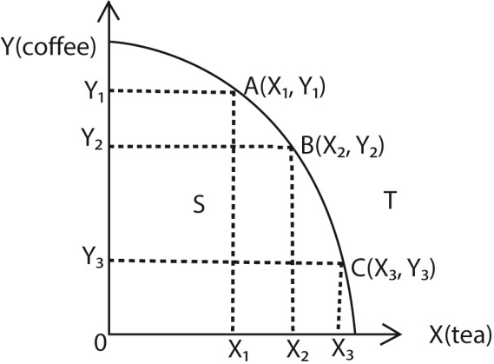
The PPF above shows that all resources are used to produce two commodities X (tea) and Y (coffee). Along the PPF curve, there are various combinations like A, B and C each representing two commodities produced in different quantities or units.
At point A, more units of Y (coffee) are produced than X (tea). And at point C more units of X (tea) are produced than Y (coffee).

Key features of the PPF
- Shows production possibilities: The curve represents the "frontier" of what is possible, showing the maximum output combinations of two goods.
- Illustrates scarcity: Because resources are limited, production cannot occur beyond the PPF curve.
- Demonstrates trade-offs: To produce more of one good, you must produce less of the other, demonstrating the trade-off involved in allocating resources.
- Indicates efficiency: Points on the curve signify that all resources are being fully and efficiently utilized.
- Represents opportunity cost: The slope of the curve at any point shows the opportunity cost of producing one more unit of a good. It is the amount of the other good that must be sacrificed. For instance, if moving along the curve means giving up 10 units of a good X to produce 5 more units of Y, the opportunity cost of those 5 units of Y is 10 units of X.
- Reveals different costs:
  - A bowed-out (concave) curve shows an increasing opportunity cost.
  - A straight line shows a constant opportunity cost.
- Highlights inefficiency: Points inside the PPF represent a state of inefficiency, as more of both goods could be produced with the existing resources.
- Shows unattainability: Points outside the curve are unattainable with current resources and technology.
- Illustrates economic shifts: The PPF can shift outwards due to economic growth, which can be caused by factors like an increase in resources (labor or capital) or technological advancements.

Economic growth
Economic growth; this refers to the persistent increase in the volume of goods and services produced in a country in a given time. Economic growth is illustrated on PPF by the outward shift of the curve to points like T as illustrated below;
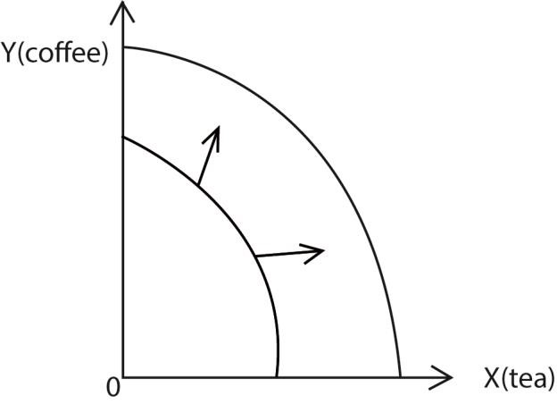
T

The outward shift can be as a result of the following factors
- Improvement in technology through innovations and inventions. Innovation refers to the improvement on the existing techniques and methods of production while invention refers to the total discovery of new techniques and methods of production.
- Increase in labour force.
- Improvement in the existing infrastructure.
- Political stability.
- Discovery of new resources in in the economy, (vi) Increase in capital stock.
- Improvement in entrepreneurial skills.
- Increase in the efficiency of workers

Economic systems
Economic systems are how societies organize the production, distribution, and consumption of goods and services.

Types of economic systems
1. Traditional economy:
It is based on customs, traditions, and historical practices. Often involves bartering and is common in smaller societies. Activities like farming and crafting are often passed down through generations.

2. Market (Free enterprise/Laissez fair) Economy
This is an economic system where productive resources are owned, controlled and allocated by private individuals without government intervention. Resources are allocated by forces of demand and supply. Also known as capitalism or free enterprise.

Feature (Characteristics) of a Market Economy
- Private property: Individuals and private businesses own the factors of production, such as land, labor, and capital. They have the right to control, use, and benefit from this property.
- Freedom of choice for consumers: Consumers have the freedom to decide what goods and services to purchase based on their needs and preferences.
- Freedom of choice for Producers: Producers are free to decide what to produce, how to produce it, and what prices to charge.
- Competition: Businesses compete with one another to attract customers, which drives innovation, encourages efficiency, and can lead to lower prices and higher quality products for consumers.
- Price system (Supply and demand): Prices are determined by the interaction of supply and demand in the marketplace. They act as signals that guide producers and consumers in their decision-making.
- Limited government role: The government's role is generally limited to establishing a legal framework for the economy, enforcing contracts, and ensuring fair competition. It does not typically control production or set prices.
- Profit motive: Businesses are motivated by the desire to make profits, which encourages them to efficiently meet consumer demand and innovate.
- Voluntary exchange: The economy functions through a system of voluntary exchanges between buyers and sellers.

Advantages of free market economy

- Economic growth and efficiency: Competition and the profit motive incentivize businesses to work harder and produce more, leading to greater economic growth and a more efficient use of resources.
- Innovation: The freedom to innovate and the potential for significant rewards encourage individuals and companies to develop new ideas, products, and services.
- Consumer choice and satisfaction: A wide variety of products and services are available because businesses are focused on meeting consumer demand and what customers are willing to pay for.
- Competition: Open competition among businesses leads to better quality products, more competitive pricing, and a greater variety of choices for consumers.
- Economic and individual freedom: A free market allows individuals and businesses the freedom to pursue opportunities, make their own choices, and keep the wealth they create, which can also lead to greater political freedom.
- A market economy promotes entrepreneurship; because the emphasis within a market economy is on innovation, it creates an environment where entrepreneurship can thrive.
- Market economies tend to provide more jobs; because it allows very many small firms to thrive thereby creating employment.
- It reduces government expenditure in form of administrative costs. This is because it does not require government officials to monitor the economic activities.

Disadvantages (demerits) free market economy
- Wealth and income gaps: Free markets can lead to substantial inequality because there is no government-mandated social safety net, such as free healthcare or welfare benefits.
- Poverty: Some individuals may live in poverty due to a lack of skills or unemployment, as there are no programs to support them.
- Monopolies: Powerful firms can dominate markets, leading to higher prices for consumers.
- Environmental damage: Businesses may ignore negative externalities like pollution because the cost of environmental damage is not reflected in the price of goods.
- Missing markets: Goods and services that are beneficial to society but not profitable, such as some types of research or public goods, may not be provided at all.
- Boom and bust cycles: Free markets are prone to instability, with cycles of economic booms followed by recessions and unemployment.
- Worker exploitation: Without government regulation, firms may offer poor working conditions and low wages to maximize profits.
- Poor quality: Without regulation, companies may produce low-quality goods to reduce costs.
- Inefficient resource allocation: The market may not allocate resources effectively to sectors that are not highly profitable but are vital for the long-term well-being of society.

- Unemployment – Unemployment may rise as there is no government check in the market.
- It leads to production and consumption of harmful products in the economy. Such goods include cocaine, marijuana, alcohol etc. This leads to deterioration in the standards of living of the consumers.
- It leads to resource wastage through excessive advertisement and duplication of goods and services. This leads to misallocation of resources in the economy.
- It leads to divergence between private and society interests. This is because private individuals may maximize profits at the expense of the society in terms of negative externalities like environmental pollution in terms of noise and water pollution.

(xiv) Consumer exploitation through misleading adverts

3. Command (Planned /centralized) Economy
This is an economic system where the resources are owned, controlled and allocated by the government (state) on behalf of its citizens. Planning and major economic decisions are made by the state (the planning authority).

Features (characteristic) of a Planned Economy
- Centralized decision-making: The government determines what goods and services are produced, how much, and at what price.
- Resource allocation by the state: Land, labor, and capital are distributed according to government plans rather than market forces.
- Price and wage control: The government sets prices and wages to maintain stability and equality.
- Focus on social welfare: The system aims to provide equal employment opportunities and ensure basic needs are met for all citizens.
- Absence of competition: Since production is state-controlled, private competition is minimal or nonexistent.
- Long-term planning: Economic activities are guided by multi-year plans (like the Soviet Union’s Five-Year Plans).
- Limited consumer choice: Consumers have fewer options because production is based on government priorities rather than demand.
- Public ownership: Industries, resources, and enterprises are owned and managed by the state
- Profit in not the main objective, instead the government aims to provide goods and services to everybody.

Advantages (Merits) of the Planned Economy

- Full utilization of resources: Central planning reduces unemployment of land, labor, and capital by ensuring they are all used productively.
- Mass production and economies of scale: Large-scale production organized by the state lowers costs and increases efficiency.
- Provision of essential goods: The government ensures that necessities like healthcare, education, defense, and power are available to all citizens.
- Reduced inequality: Wealth and income are distributed more evenly since the government controls wages and prices.
- Economic stability: Centralized control avoids extreme fluctuations in supply, demand, and prices, reducing inflation and unemployment.
- Focus on long-term goals: Governments can prioritize infrastructure, industrialization, or social development without being constrained by short-term profit motives.
- Protection from exploitation: Workers and consumers are safeguarded from monopolies and unfair practices because the state regulates production and distribution.
- Affordable market prices because monopolies are controlled
- The system can cope up with the rapid structural changes. For example drought, famine, etc. through proper planning by the central planning authority.
- It controls the production and consumption of harmful products the economy. The government is in position to regulate the production of such commodities like alcohol and cigarettes through taxation. This helps to improve on the standards of living of the citizens.
- Some key areas like production of fire arms cannot be left in the hands of private individuals. This is because it may cause insecurity in the country hence the need for the planned economy,

Disadvantages (demerits) of a planned economy
- Inefficiency in resource allocation: Central planners may misjudge demand, leading to shortages or surpluses.
- Lack of innovation: With little competition and no profit incentive, firms have fewer reasons to innovate or improve quality.
- Bureaucracy and delays: Decision-making is slow due to heavy government involvement and rigid planning structures.
- Limited consumer choice: Goods and services are produced based on government priorities, not consumer preferences.
- Risk of corruption: Concentrated power in the hands of planners can lead to favoritism or misuse of resources.
- Poor responsiveness to change: Planned economies struggle to adapt quickly to new technologies, global trends, or crises.
- Low worker motivation: Without performance-based rewards, productivity can suffer, and workers may lack incentives to excel.
- Potential for stagnation: Long-term growth can be hindered when innovation and efficiency are sacrificed for stability.
- High resource wastage: Lot of time and money is wasted in communicating instructions from the government to the firms.
- It can lead to imbalance of regional resource allocation and development. This is due to state influence in resource distribution basing on political support

4. Mixed economy
This is an economic system where the productive resources are owned, controlled and allocated by both the government and private individuals. Decision making and planning is done by both the private individuals and the state for example, Uganda.

Features/characteristics of mixed economy
- Coexistence of public and private sectors: Both government-owned enterprises and privately-owned businesses operate side by side.
- Government regulation: The state intervenes to correct market failures, regulate monopolies, and ensure social welfare.
- Freedom of enterprise: Individuals and firms can own property, start businesses, and engage in trade, but within legal limits.
- Social welfare objectives: The government provides essential services like healthcare, education, and infrastructure to ensure equity.
- Price mechanism with control: Market forces determine most prices, but the government may fix or regulate prices for essential goods.
- Balanced resource allocation: Resources are distributed through both market demand and government planning.
- Protection of consumer rights: Laws safeguard consumers against exploitation and ensure fair competition.
- Economic planning: Governments use policies and plans to guide development while leaving room for private initiative.
- Production is for both profits and welfare maximization

Revision Questions

Section A questions
- (a) Distinguish between positive statements and normative statements as used in economics
  - Give 2 examples of normative statements.
- (a) Distinguish between scarcity, choice and opportunity cost
  - Explain how scarcity is related to choice and real cost
- (a) Define the term real cost .
  - Give any three uses of opportunity cost concept to the producer
- (a) Distinguish between Micro-economics and macro-economics.
  - Give three assumptions underlying the production possibility frontier.
- Identify four circumstances under which the concept of opportunity cost is applied in economics
- Give four limitations of the concept of opportunity cost in resource-allocation?
- (a) What is meant by a transformation curve.
  - Mention three factors that may lead to a shift in the transformation curve
- (a) Define the term a "want"
  - Mention any three features of e want
- (a) Define the term scale of preference
  - State any three economic questions.
- (a) Distinguish between a free good and an economic good (b) State four traits of an economic good.
- (a) What is meant by the term wealth
  - Give three characteristics of wealth
- (a) Define a market economy
  - Mention any three features of the market economy 13. (a) Distinguish between a merit good arid a public good (b) Give two examples of merit goods.
- Outline four features of public goods
- (a) Distinguish between substitutes and complements
  - Give two examples of complements,
- Distinguish between the following types of goods
(a} Capital goods and intermediate goods
  - Inferior goods and Giffen goods
  - Substitute goods and complementary goods
- (a) What is meant by a "laissez faire" Economy
  - Give three features of a "laissez faire" Economy.
- (a) Distinguish between a barter economy and a command economy (b) Give four features that qualify Uganda as a mixed economy.
- (a) Define the term "price" as used in economics
  - Mention three circumstances under which the production possibility curve may shift outwards
- Outline four characteristics (features) of a market economy

Section B questions

1 (a) Distinguish between a command economy and a market economy
(b) What are the advantages and disadvantages of a market economy? 2 (a) w h at is meant by a planned economy. .
(b) Explain the advantages and disadvantages of a planned economy

TOPIC 2/2: Price Theory
Competency: The learner supports community actors on the efficient allocation of resources, by analysing data on market behaviour and household consumption concerning community welfare.

Market concept
A market is any arrangement where buyers and sellers come together to exchange goods and services.
Markets can be physical like a retail outlet, or virtual like an e-retailer

Price theory
Price theory explains how supply and demand set prices, which in turn shape consumer choices, producer strategies, and resource allocation.

Core Ideas of Price Theory
- Definition: Price theory studies how the value of goods and services is expressed in monetary terms, focusing on exchange in markets.
- Supply and demand interaction: Prices rise when demand exceeds supply and fall when supply exceeds demand.
- Market equilibrium: The point where supply equals demand determines the stable price of a good or service.
- Consumer behavior: Consumers aim to buy at the lowest possible price, influencing demand patterns.
- Producer behavior: Producers seek to maximize profit by charging the highest feasible price.
- Resource allocation: Prices act as signals, directing resources to their most valued uses in the economy.
- Foundation of microeconomics: Price theory underpins the study of individual consumer and producer decisions, making it central to microeconomic analysis.

Limitations of Price Theory
- Ignores non-market factors: Social values, government policies, and externalities (like pollution) are not fully captured.
- Assumes rational behavior: Real-world decisions may be influenced by psychology, culture, or imperfect information.
- Static analysis: Price theory often assumes conditions remain constant, which is unrealistic in dynamic economies.

Price
Price is the monetary value assigned to a good, service, or resource, determined during a transaction between buyers and sellers at a given time.
OR.
Price is the amount of money which must be given up in order to obtain a commodity in a
given, market at a given time . . ,

Types of Markets (Market structure)
Markets are classified into four main types based on competition. Market structures explain how competition works and how prices, profits, and consumer choices are shaped.

(a) Perfect Competition
- Many sellers: A large number of sellers exist in the market.
- Homogeneous products: All sellers offer identical products, meaning they are similar in shape, size, and quality.
- Price determined by market: The price is set by the market forces of supply and demand, and individual sellers cannot influence it.
- the freedom of entry into and exit out of the industry or perfect resource mobility - Perfect knowledge of prices and technology.
- No price control.
- Perfect mobility of factors of production, the factors of production are completely mobile leading to factor-price equalization throughout the market.
- the consumer has plenty of choice when buying goods or services

(b) Monopoly
- Single seller: There is only one seller or firm in the entire market.
- Unique product: The product has no close substitutes.
- Barriers to entry: The single seller has a significant advantage, often due to high barriers preventing other companies from entering the market.

(c) Monopolistic Competition
- Many sellers: Like perfect competition, there are many sellers.
- Differentiated products: Sellers offer products that are closely related but differentiated through branding, features, or other characteristics.
- High advertising costs: Firms may incur high costs for advertising to emphasize their product's uniqueness.
- Free entry and exit: Companies can easily enter or leave the market.

(d) Oligopoly
- Few sellers: The market is dominated by a small number of large sellers.
- Interdependence: The decisions of one seller regarding price and output significantly impact the decisions and outcomes of other sellers in the market.
- Products can be identical or differentiated: The products can be identical or have some level of differentiation.

Why Market Types Matter
- They determine pricing power (who sets prices).
- They shape consumer choice (variety vs. limitation).
- They influence innovation and efficiency (competition drives progress, monopolies may stagnate).
- They affect barriers to entry (easy in perfect competition, hard in oligopoly/monopoly).

Methods of Price determination in the Market
Methods of price determination reflect the structure of the market (competitive, monopolistic, regulated) and the economic goals (profit maximization, consumer protection, or social welfare).
- Market equilibrium method: Price is set where demand equals supply; this is the most common mechanism in free markets.
- Government intervention: The state may fix or regulate prices of essential goods (e.g., fuel, medicine) to protect consumers.
- Cost-plus pricing: Producers set prices by adding a profit margin to production costs.
- Monopoly pricing: A single seller controls supply and sets prices higher due to lack of competition.
- Oligopoly pricing: A few firms dominate; prices may be set through collusion or competitive strategies.
- Discriminatory pricing: Different prices are charged for the same product in different markets (e.g., airline tickets, electricity tariffs).
- Auction method: Prices are determined by bidding, common in real estate, art, or stock exchanges.
- Bargaining method: Price is negotiated between buyer and seller, typical in informal markets.
- Administered pricing: Prices are set by large firms or government agencies regardless of supply-demand forces.
- Price leadership. This is where a large and low cost firm in the industry fixes the price of a commodity which has to be followed by other small firms. This firm normally has a large share of the market.
- Resale price maintenance. This is where the producer (manufacturer) fixes the price of a commodity at which the seller (retailers) has to sell to the final consumers. The price is usually written the commodity container. For example Newspapers, soft drinks. etc.

Advantages (merits) of resale price maintenance
- It is time saving since it does not involve bargaining - It reduces unnecessary competition among sellers.
- It helps to control consumer exploitation in form of increasing prices by sellers/retailers.
- It helps to maintain price stability.
- It helps to reduce on the duplication of the products by other producers.

The theory of demand

Demand refers to the quantity of a good or service that consumers are willing and able to purchase at different prices during a given period of time.

It's important to note that demand is not the same as desire; it requires both the desire to buy and the ability to pay.

Quantity demanded refers to the specific amount of a good or service that consumers are willing and able to purchase at a given price during a particular period of time.

Key Features of Quantity Demanded
- Specific amount: It is the exact number of units consumers buy at a certain price.
- Depends on price: If the price changes, the quantity demanded changes accordingly.
- Time-bound: Always measured over a specific period (e.g., per day, per month).
- Movement along the demand curve: A change in price leads to a change in quantity demanded, shown as movement along the curve.
- Ceteris paribus condition: Assumes other factors (income, tastes, prices of related goods) remain constant.

Example
- If the price of sugar is UGX 5,000 per kg, and consumers buy 100 kg, that is the quantity demanded.
- If the price falls to UGX 4,000 per kg, and consumers buy 150 kg, the new quantity demanded is 150 kg.

Determinants of quantity demanded
Quantity demanded is influenced by several factors beyond just the price of a good. These are called the determinants of quantity demanded, and they explain why consumers buy more or less of a product at a given price.
- Price of the good: The most direct factor; lower prices increase quantity demanded, higher prices reduce it.
- Income of consumers: Higher income generally increases demand for normal goods, but may reduce demand for inferior goods.
- Prices of Substitutes (e.g., tea vs. coffee): if the price of one rises, demand for the other increases.
- Prices of Complements (e.g., cars and fuel): if the price of one rises, demand for the other falls.
- Tastes and preferences: Fashion trends, advertising, and cultural shifts can increase or decrease demand.
- Expectations of future prices: If consumers expect prices to rise, they buy more now; if they expect a fall, they delay purchases.
- Population size and composition: Larger populations or demographic changes (like more youth) affect demand for specific goods.
- Seasonal factors: Demand for certain goods (e.g., umbrellas, heaters, holiday items) varies with seasons or events.
- Government policies: Taxes, subsidies, and regulations can raise or lower demand. For instance, an increase in taxes on the commodity by the government leads to a decline in quantity demanded of the commodity but subsidization to consumers by the government encourages the consumption of the commodity and therefore quantity demanded Increases.
- Advertising: Effective advertising campaigns can increase a product's appeal and shift consumer preferences in its favor.
- Religion and culture The demand for pork is low in places where there are many Moslems as compared to places where there are many Christians especially Catholics.
- Sex of the consumer. Some commodities are demanded by a particular sex e.g. the demand for shirts is likely to be high in places where there are many males as compared to females. Also, the demand for sweets is likely to be high in a girls' school as compared to a boys' school.
- Marital status. For example, the demand for wedding rings is high in a society where there are many married couples as compared to that dominated by singles.
- Level of education. For example, the demand for scholastic materials is high in places where there are many people going to school as compared to places where there are few students.

Demand curve
The demand curve is a graphical representation of the relationship between the price of a good and the quantity demanded by consumers over a given period of time.

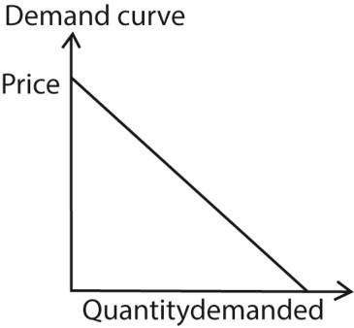

The graph shows that increase in price leads to reduction in quantity demanded and vice versa

Reasons why demand curve slopes down from left to right
- Law of Demand: As price falls, consumers buy more; as price rises, they buy less.
- Substitution effect: When the price of a good falls, it becomes cheaper compared to substitutes, so consumers switch to it.
- Income effect: A fall in price increases consumers’ real income (purchasing power), allowing them to buy more.
- Diminishing marginal utility: Each additional unit of a good gives less satisfaction; consumers will only buy extra units if the price drops.
- Entry of new buyers: Lower prices attract more buyers who previously could not afford the good.
- Multiple uses of goods: At lower prices, goods may be used for additional purposes (e.g., electricity for both lighting and heating).

Change in demand
This refers to increase or decrease in amount of the commodity bought due to changes in other factors affecting demand keeping price of the commodity constant. It involves a shift in demand curve either to the left or to the right
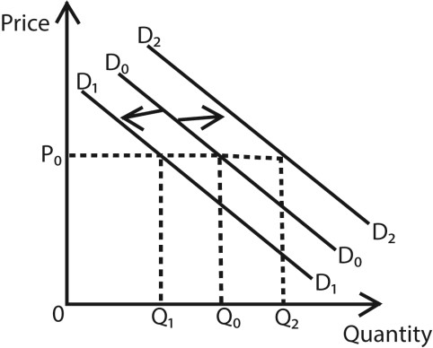

Increase in demand
It is indicated by a shift in the demand curve to the right (from D ₀ D ₀ to D₂ D₂ ). It refers to the outward shift in the demand curve caused by the favorable factors which affect demand at constant price of the commodity.

Factors that favor an increase in demand at constant price
- Increase in consumer income: Higher incomes allow people to buy more goods and services.
- Favorable Change in tastes and preferences: Trends, advertising, or cultural shifts make a product more desirable.
- Rise in population: More people (or specific demographic groups) increase overall demand.
- Price of substitutes rising: If tea becomes expensive, demand for coffee increases at the same price.
- Price of complements falling: If fuel becomes cheaper, demand for cars increases even if car prices remain constant.
- Expectations of future price increases: Consumers buy more now to avoid paying higher prices later.
- Favorable Seasonal or climatic changes: Demand for umbrellas rises in rainy seasons, or demand for ice cream rises in hot weather.
- Government policies: Subsidies, tax cuts, or favorable regulations can boost demand.
- Improved distribution and availability: Easier access to goods (e.g., through supermarkets or online platforms) increases demand.

Decrease in demand
It is indicated by a shift in the demand curve to the left (from D₀D₀ to D₁D₁). It refers to an inward shift in the demand curve caused by the unfavorable factors which affect demand at constant price of the commodity.

Factors that cause a decrease in demand at constant price

- Fall in consumer income: With less purchasing power, people reduce consumption of normal goods.
- Change in tastes and preferences: If a product goes out of fashion or loses appeal, demand drops.
- Decrease in population: Fewer consumers in the market reduce overall demand.
- Price of substitutes falling: If tea becomes cheaper, demand for coffee decreases at the same price.
- Price of complements rising: If fuel prices rise, demand for cars falls even if car prices remain constant.
- Expectations of future price falls: Consumers delay purchases if they expect prices to drop later.
- Unfavorable Seasonal or climatic changes: Demand for heaters falls in summer, or demand for umbrellas falls in dry seasons.
- Government policies: Higher taxes, bans, or restrictions reduce demand for certain goods.
- Poor distribution or availability: If goods are hard to access, demand decreases even if prices remain unchanged.

Types of demand

- Price demand: Demand that changes with the price of the good itself.
- Income demand: Demand influenced by changes in consumer income.
- Competitive demand: When different goods compete to satisfy the same need (e.g., butter vs. margarine).
- Joint (complementary) demand: When two or more goods are demanded together (e.g., cars and fuel; gun and bullets).
- Composite demand: When a good is demanded for multiple uses (e.g., electricity for lighting, heating, and machinery).
- Direct demand and Derived demand: Direct demand is for consumer goods; derived demand is for goods needed to produce other goods (e.g., steel for cars).
- Cross demand: Demand affected by the price of related goods (substitutes or complements).
- Individual demand and Market demand: Individual demand is for a single consumer; market demand is the sum of all consumers’ demand.
- Independent (unrelated) demand. This refers to the demand for commodities which are not related such that the demand for one commodity does not directly affect the demand of another commodity. For example demand for a car and a pen, clothes and sugar.

Aggregate demand
Aggregate demand is the total demand for all final goods and services in an economy at a given price level and time period. Formula
Aggregate Demand (AD): 𝐶+𝐼+𝐺+(𝑋−𝑀)
Where C: Consumption expenditure by households
I: Investment spending by businesses
G: Government spending
X: Total exports
M: Total imports

Aggregate demand curve
The aggregate demand (AD) curve shows the relationship between the overall price level in an economy and the total quantity of goods and services demanded (real GDP) during a given period.

Key Features of the Aggregate Demand Curve
- Downward sloping: Indicates an inverse relationship between the price level and real GDP demanded.
- Axes: o Vertical axis (Y-axis) → Overall price level.
o Horizontal axis (X-axis) → Real GDP (output demanded).
- Not just about one good: Unlike a normal demand curve, the AD curve represents demand for all goods and services in the economy.
Aggregate demand curve is the horizontal summation of all individual household demand curves.
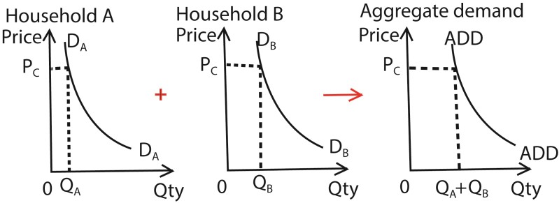
Note that different reasons account for down slopping of a demand curve (one product) and aggregate demand curves (many products)

Reasons Why the AD Curve Slopes Downward
- Wealth effect: A lower price level increases the real value of money, boosting consumption.
- Interest rate effect: Lower prices reduce interest rates, encouraging investment and spending.
- Net export effect: Lower domestic prices make exports cheaper and imports more expensive, increasing net exports.

Example
If the overall price level in Uganda decreases, households feel wealthier, businesses borrow more cheaply, and exports become more competitive. This increases total demand for goods and services, shifting the economy to a higher real GDP.

The factors which affect the level of aggregate demand
- Consumer spending: Changes in household income, wealth, confidence, and credit availability directly affect consumption.
- Investment spending: Business confidence, interest rates, technological progress, and cost of capital drive investment levels.

- Government expenditure: Fiscal policies such as taxation, subsidies, and public spending on infrastructure or social programs influence demand. For example, if the government increases public spending on roads and energy projects, aggregate demand rises
- Net exports: Exchange rates, global demand, and trade policies determine how much a country sells abroad versus imports.
- Interest rates: Lower interest rates encourage borrowing and spending, while higher rates reduce demand. For instance, if interest rates increase, borrowing becomes expensive, reducing investment and consumption, and aggregate demand falls.
- Expectations: If consumers and businesses expect future growth, they spend more now; pessimism reduces demand.
- Tax policies: Higher taxes reduce disposable income and demand, while tax cuts stimulate spending.
- Wealth effect: Rising asset values (like housing or stocks) make consumers feel richer, boosting demand.
- Global economic conditions: Recessions or booms in trading partners affect exports and overall demand.
- The distribution mechanism of good and services: When the distribution of goods and services is poor, the level of aggregate demand will be low and vice versa.
- The size of the population: high population increase purchasing power and aggregate demand and vice versa.
- The political climate in the country. A stable conducive political climate increase the purchasing power leading to increase in aggregate demand

Abnormal (Regressive/exceptional) demand curves
An abnormal demand curve is one that does not follow the law of demand; that is, demand may increase as price rises or decrease as price falls, creating unusual shapes different from the normal that slopes from left to right.

Causes of the Abnormal demand curve
- Giffen goods effect: For certain inferior goods (like staple foods), when price falls, consumers may buy less because they can now afford better substitutes. Example: If maize flour becomes cheaper, low-income households may shift to rice, reducing maize demand.
- Veblen effect (conspicuous consumption): Luxury goods are demanded more at higher prices because they signal prestige or status. Example: Designer clothes, luxury cars, or jewelry.
- Expectation of future price changes: If consumers expect prices to rise further, they may buy more even at higher prices. Example: Housing markets, where buyers rush to purchase before prices climb higher.
- Necessities with no substitutes (perfectly inelastic demand): Some goods are essential, and demand remains constant regardless of price. Example: Life-saving medicines, salt or basic utilities like water.
- Consumer psychology and prestige bias: Some buyers associate higher prices with better quality, so demand increases with price.
- Speculative demand: In markets like stocks or property, rising prices may attract more buyers hoping for further gains.
- Network Effects: Some products, especially in the technology sector, become more valuable as more people use them (e.g., social media platforms). This can lead to increased demand even as the price rises because the increased user base enhances the product's value for everyone.
- Scarcity: In situations of extreme scarcity, such as a limited edition collectible, demand can rise as the price increases because the item is perceived as more valuable and exclusive.
- Ignorance effect of the consumers. Some consumers may buy more units of the commodity at high prices due to their ignorance about the existing market price. This is normally due to persuasive advertisement sellers hence violating the law of demand.
- Depression effect. A depression is an economic situation where all economic activities are at low levels e.g. low prices, low incomes, low investment levels etc. In such situations when the price of the commodity reduces, quantity demanded remains low due to the low purchasing power of consumers as a result of low incomes. This violates the law of demand.
- Addiction (Habit) to the consumption of the commodity. This violates the law of demand in such a way that increasing the price of the commodity may not reduce the quantity demanded of that commodity to a consumer who is addicted to consuming that commodity, e.g. smokers
- Special seasons (occasions). For example, during Christmas seasons, wedding occasions etc. In such seasons, the demand for certain commodities increases with an increase in their prices due to high need for them. For example the demand for fruits increases during Idd season.
Summary: Abnormal demand curves occur due to special circumstances—poverty-driven consumption (Giffen goods), prestige-driven consumption (Veblen goods), expectations, or necessity. They highlight that consumer behavior is not always rational and can defy the standard law of demand.

The supply theory

The theory of supply states that, all other factors being equal, a rise in the price of a good or service will lead to an increase in the quantity supplied

This is because producers are incentivized to supply more when they can get a higher price for their products. The theory is represented by an upward-sloping market supply curve, where price and quantity supplied have a positive relationship.

Supply curve
This is a graphical representation of the law of supply. It shows the relationship between the price of a good and the quantity that producers are willing to offer for sale. The curve slopes upwards from left to right.
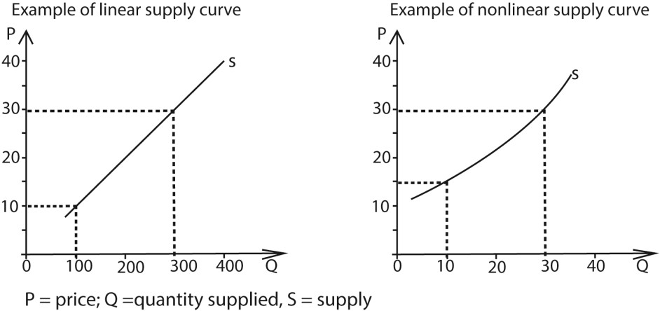

Supply vs. Quantity Supplied
It's important to distinguish between the two.
Aspect | Supply | Quantity Supplied
Definition | Refers to the entire relationship between price and the amount producers are willing to sell. | Refers to the specific amount of a good  producers are willing to sell at a particular price.
Representation | Shown as the whole supply curve. | Shown as a point on the supply curve.
Cause of Change | Changes due to non-price factors (technology, production costs, taxes, subsidies, expectations, number of sellers). | Changes due to price of the good itself.
Effect | A change in supply shifts the entire curve left or right. | A change in quantity supplied causes movement along the curve (up or down).
Example | If government gives subsidies, supply of maize increases (curve shifts right). | If maize price rises from UGX 2,000 to UGX 2,500 per kg, farmers supply more maize (movement along curve).

Key Takeaway
- Supply = the overall curve (relationship between price and quantity).
- Quantity supplied = a single point on that curve (specific amount at a given price).

Supply Schedule
A supply schedule is a table that shows the relationship between the price of a good and the quantity supplied of that good over a given period of time. It is the numerical representation of the law of supply.

Example of supply schedule of maize floor by the farmers at different prices
Price
(
Ug.shs
)

500

1000

1500

2000

2500

Quantity

20

25

30

35

40

Factors affecting supply:
Changes in factors other than price, such as the cost of production, technology, and the number of producers, will shift the entire supply curve.

Factors affecting q u a n t i t y supplied o f the commodity
- Price of the commodity itself: As price rises, producers supply more; as price falls, they supply less.
- Time period considered: In the short run, producers may not adjust quickly, but in the long run they can expand production.
- Stock availability: If producers have large inventories, they can increase supply quickly when prices rise.
- Capacity utilization: Firms with unused capacity can respond faster to price changes by increasing output.
- Perishability of the commodity: For perishable goods (like fruits or milk), producers may supply more immediately when prices rise, but cannot hold back supply for long.
- The number of producers of the commodity. The higher the number of producers of the same commodity the greater the quantity supplied, and the smaller the number of suppliers, the lower the quantity supplied:
- Level of costs of production. A reduction in the factor prices reduces the cost of production and this leads to an increase in supply but an increase in the costs of production discourages producers and this leads to a fall in the quantity supplied.
- Degree of availability of factor inputs. An increase in the supply of factor inputs in form of raw materials increases quantity supplied of the commodity but a reduction in the supply of factor inputs reduces the quantity supplied of the product.
- Degree of freedom of entry of firms in production. Free entry of firms increases the supply of the commodity while restricted e n t r y of firms reduces the supply of goods.
- Level of technology used in production. Use of better and improved technology increases quantity supplied but in case the technology used is inefficient, the quantity supplied reduces e.g. a tractor versus a hand hoe.
- Nature of the working conditions. Favorable working conditions in form of higher wages, transport and food allowances etc. motivate workers to work hard and this increases quantity supplied of the product. But unfavorable working conditions encourage workers to become inefficient a n d therefore quantity supplied of the product decreases.
- The length of the gestation period. This is the time taken for a commodity to be ready on market. The longer gestation period, the l o w e r the quantity supplied and the shorter the gestation period, t h e higher the quantity supplied.
- Goal of the firm. A firm that aims at profit maximization may put less quantity on market and charge a high price hence reducing the quantity supplied of the commodity but for the firm aiming at sales maximization, quantity supplied of the product increases.
- Government policy, increasing taxes by the government on the producers of a certain commodity increases the cost of production and this reduces quantity supplied of the product. But subsidization of producers by the government in form of reduced prices for factor inputs increases the quantity supplied of the commodity.
- The nature of the Climate. Favorable climate increases the supply of the commodity especially for the agricultural products but unfavorable climate reduces the supply of agricultural commodities.
- Degree of political stability of the country. A politically stable country encourages investments and production of goods and services hence increasing the supply of commodities. But a politically unstable country discourages the production of goods and services hence a fall in the supply of commodities.
- The size of the market, the bigger the market size, the higher the supply of the commodity and the smaller the market size, the lower the supply of the commodity.
- Future price expectations. An expected future increase in the price of the commodity by the producers reduces the current supply of the commodity. This is because they expect to sell at a higher price and earn more profits in future. But an expected future fall in the price increases the current supply of the commodity. This is because the producers want to avoid making losses by selling at lower prices in future

Change in quantity s u p p l i e d

This refers to the increase or decrease in the quantity supplied of a commodity due to change in its price keeping other factors constant. It involves the movement along the supply curve.
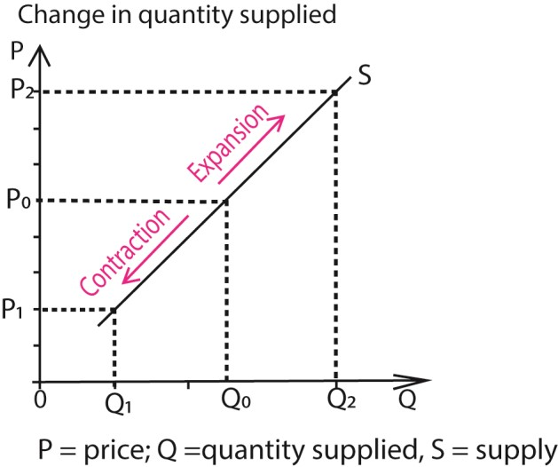

- The movement downwards the supply curve is called a contraction (decrease in quantity supplied). It is brought about by the fall in price of a commodity keeping other factors constant.
- An upward movement along the supply curve is called an expansion (increase in quantity supplied). It is brought about by increase in the price of the commodity keeping other factors constant

Change in supply
Change in supply refers to an increase or decrease i n supply due to changes in other factors affecting supply of the commodity at a constant price. OR. It refers to a shift in the supply curve brought about by the changes in other factors affecting supply at constant price of a commodity.
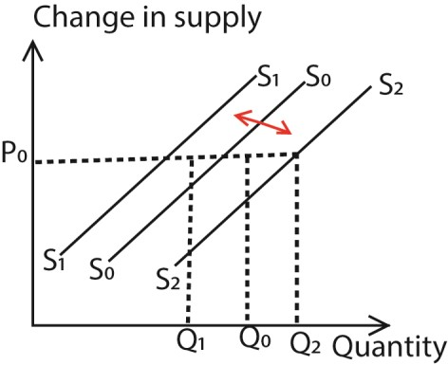
- A shift in the supply curve from S₀ to S₁ is called a decrease in supply, It refers to the shift in the supply curve to the left caused by the unfavorable factors which affect supply at a constant price.
- A shift in the supply curve from S₀ to S₂ is called a increase in supply, It refers to the shift in the supply curve to the left caused by the favorable factors which affect supply at a constant price.

Types of Supply
- Individual supply: The quantity of a commodity supplied by a single producer at different prices.
- Market supply: The total quantity supplied by all producers in the market at different prices.
- Joint supply: When two or more goods are produced together from the same resource.
Example: Crude oil refining produces petrol, diesel, and kerosene simultaneously.
- Composite supply: When a commodity can be supplied for multiple uses. Example:
Electricity supplied for lighting, heating, and industrial machinery.
- Short-run supply: Supply when some factors of production are fixed, so firms can only adjust variable inputs.
- Long-run supply: Supply when all factors of production are variable, allowing firms to fully adjust output.
- Fixed supply (perfectly inelastic): Supply that cannot change regardless of price. Example: Land or rare antiques.
- Elastic supply: Supply that responds significantly to price changes. Example: Manufactured goods where production can be scaled up quickly.
- Competitive supply. This is where the supply of one commodity leads to a reduction in the supply of another commodity. For example increasing t h e supply of beef at the expense o f milk.

Regressive (Abnormal/Exceptional) Supply curve

A regressive supply curve is one i s a n y c u r v e t h a t d o e s n o t s l o p e u p w a r d s d i c t a t e d b y t h e l a w o f s u p p l y .

Examples of regressive supply curves (a) Fixed supply curve of land in short run
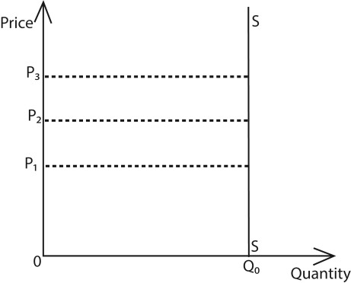

(b) Supply curve for labour
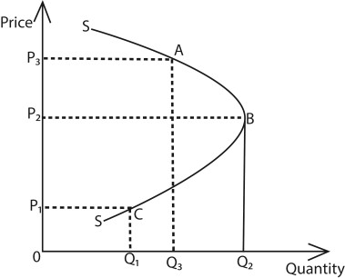

From the graph, ABC is the backward bending labour supply curve, When the wage increases from OP₁ to OP₂ labour supply increases from OQ₁ to 0Q₂, After point B, the wage increase from OP₂ to OP₃ leads to a reduction labour supply from OQ₂ to OQ₃

Causes of regressive labor supply curve
- Labour-leisure tradeoff: At low wages, workers substitute leisure for work because higher pay makes work more rewarding. At high wages, they reduce hours to enjoy more leisure.
- Substitution effect: Initially, higher wages encourage more work since the opportunity cost of leisure rises.
- Income effect: Beyond a certain wage level, workers earn enough to meet their needs and prefer leisure over extra income.
- Target income behavior: Many workers aim for a specific income level. Once achieved, they cut back on hours.
- Job satisfaction and fatigue: Higher wages don’t always offset the disutility of long working hours; workers may value rest more.
- Cultural and social preferences: In some societies, leisure, family time, or community activities are prioritized once basic financial security is reached.
- Expectations of future wages: Workers may reduce current labour supply if they anticipate sustained high wages or pensions later.
- Decline in the real wage of workers due to high levels of inflation .This forces workers to work for fewer hours.
- Use of progressive taxation by the government. That is where the tax rate increases as the income of the tax payer increases. These discourage hard work for high wage earners and are forced to work for fewer hours so as to earn a lower wage and pay fewer taxes.

Example
In Uganda, a boda-boda rider may work longer hours when fares are low to meet daily needs. But if fares rise significantly, he may reduce working hours, preferring leisure once his income target is reached.

- Speculative supply. When prices are expected to increase in future, sellers or producers
put less on market even if prices are slightly increasing. This is because they are expecting to get a lot of profits in future at very high prices.
- Supply of perishable goods. For perishables, more is supplied (put on the market) immediately after harvest. Therefore even if prices are low or decreasing, more is supplied hence violating the law of supply.
- Existence of Catastrophic periods. In such periods, supply may not increase even if prices are increasing due to scarcity of commodities.

Market equilibrium
In a competitive market, the market is in equilibrium when quantity demanded equals quantity supplied.
This is graphically illustrated as shown below
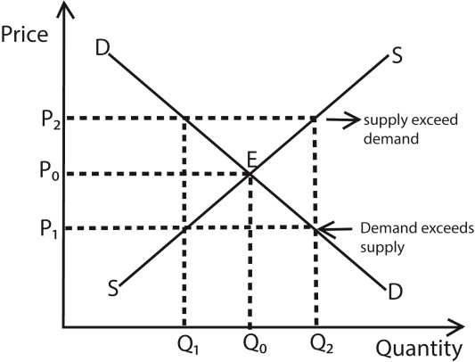
D

- At high price OP₂ supply exceeds demand and therefore a surplus of Q₀Q₂ is created. When supply is in excess, the producers decrease the price in order to sell the surplus (excess) and in the process equilibrium is restored in the market at point E.
- At lower price OP₁, quantity demanded exceeds quantity supplied therefore a shortage Q₁Q₀ is created which forces the producer (seller) to increase the price until the equilibrium point is attained at point E.

Note
- Market price refers to the prevailing (ruling) price in the market at a given time. OR. Market price is any price determined by the buyers and sellers in the market irrespective of whether quantity demanded is equal to quantity supplied at a given.
- Equilibrium price refers to the market price where quantity demanded is equal to quantity supplied.
- Normal (natural) price refers to the long run equilibrium price established in the market after a long period of price fluctuations.
- Reserve price refers to the minimum price set by the seller below which he is not willing to sell his commodity.
- Reserve wage refers to the minimum wage set by a worker below he is not willing to work/offer services.

Determinants of Reserve price
- Cost of production: Sellers often set the reserve price at or above the total cost of producing the good (including raw materials, labor, overheads).
- Desired profit margin: The reserve price usually includes a markup to ensure profitability.
- Market conditions: If demand is high and supply is limited, sellers may set a higher reserve price. In weak markets, reserve prices may be lowered to attract buyers. (iv) Quality and uniqueness of the commodity:
Rare, high-quality, or unique items (like antiques or luxury goods) justify higher reserve prices.
- Seller’s expectations and objectives: A seller aiming for quick sales may set a lower reserve price, while one seeking maximum returns sets it higher.
- Competition in the market: More competitors may push reserve prices lower, while monopolistic or niche markets allow higher reserves.
- Government policies and regulations: Taxes, subsidies, or price controls can influence the minimum acceptable price.
- Risk and uncertainty: Sellers may set higher reserve prices to hedge against inflation, currency fluctuations, or future scarcity.
- Time constraints: Urgent need for liquidity (e.g., financial distress) may force sellers to lower reserve prices.
- Degree of durability of the commodity. The higher the degree of durability of the commodity, the higher the reserve price and the more perishable the commodity is the lower the reserve price
- Degree of necessity of the commodity. The higher the degree of necessity, the lower the reserve price and the lower the degree of necessity, the higher the reserve price.
- Level of storage expenses. The higher the storage expenses, the lower reserve price and the lower the storage expenses, the higher the reserve price.

Example
In Uganda, a coffee exporter may set a reserve price based on production costs, international demand, and expected profit margins. If global coffee prices rise, the reserve price increases; if demand falls, the exporter may lower it to remain competitive.

Significance (Importance or uses) of prices in the economy
- Resource allocation: Prices signal where resources should go. High prices attract producers to supply more, while low prices discourage production.
- Consumer decision-making: Prices help consumers decide what to buy, how much, and when. They balance needs against budgets.
- Producer incentives: Rising prices encourage producers to increase supply, invest in production, or innovate. Falling prices discourage output.
- Equilibrium determination: Prices bring demand and supply into balance, ensuring markets clear without persistent shortages or surpluses.
- Income distribution: Prices influence wages, rents, and profits, shaping how income is shared among workers, landowners, and entrepreneurs.
- Economic efficiency: Prices ensure goods are produced at the lowest possible cost and consumed by those who value them most.
- Signals of scarcity or abundance: High prices indicate scarcity, prompting conservation or substitution. Low prices signal abundance.
- Stabilization role: Flexible prices help economies adjust to shocks (like droughts, inflation, or global demand changes).
- International trade: Prices determine competitiveness in global markets, affecting exports and imports.

Example
- In Uganda, if coffee prices rise globally, farmers allocate more land to coffee instead of maize.
- Consumers, meanwhile, adjust their spending when fuel prices rise, perhaps reducing car use or switching to boda-bodas.

Elasticity of demand
This is the measure of degree of responsiveness of quantity demanded due to changes in the factors which influence quantity demanded.

Types of Elasticity of demand

(a) Price elasticity of demand
This is the measure of the degree of responsiveness of quantity demanded due to changes in the price of the commodity.

The negative is multiplied in the formula because of the negative relationship between quantity demanded and the price of the commodity. If PED > 1 → Elastic demand (very responsive).
If PED < 1 → Inelastic demand (not very responsive). If PED = 1 → Unitary elastic demand.

Examples 1
A change in price form 10/= to 15/= lead to a reduction in quantity from 24 to 20. Calculate price elasticity of demand
Percentage change in quantity demanded = 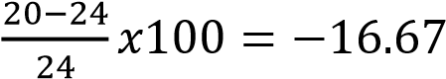
Percentage change in price =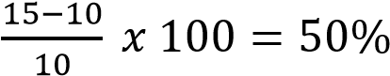

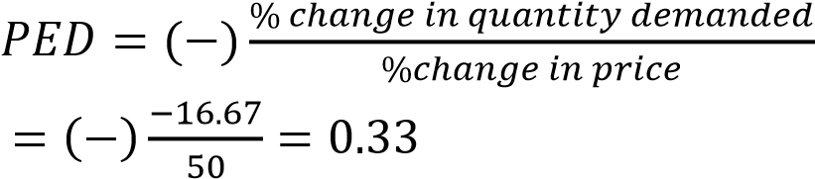

Example 2
A 20% change in price of a commodity led to a fall in quantity demanded of the commodity from 40 to 20 units. Calculate price elasticity of demand.
Percentage change in price =20%
Percentage change in quantity = 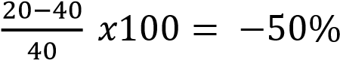
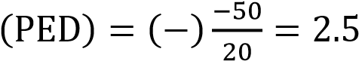

Interpreting price elasticity of demand
(i) Perfectly inelastic demand (E_{P}= 0). This is when price elasticity of demand equals to zero. Here the quantity demanded does not respond to changes in price at all.

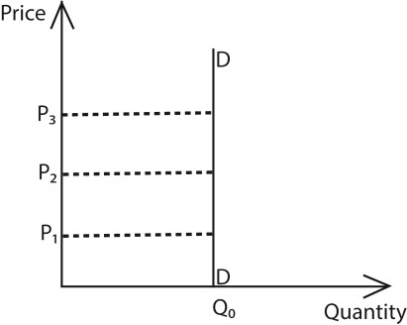

From the graph a change in price from OP₁ to OP₂ to OP₂ leaves quantity demanded u n c h a n ge d at 0Q₀. (ii) Inelastic demand (0 < Ep<1)
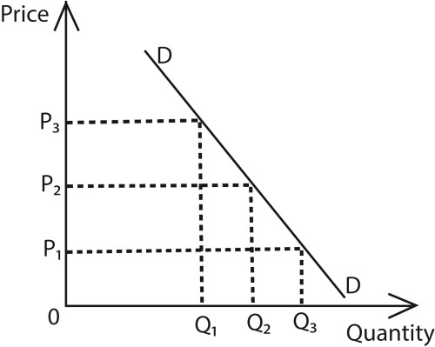
In this case, the price elasticity of demand is greater than zero but less than one. A big proportionate change in price leads to a smaller percentage change in quantity demanded.

(iii) Unitary elasticity of demand
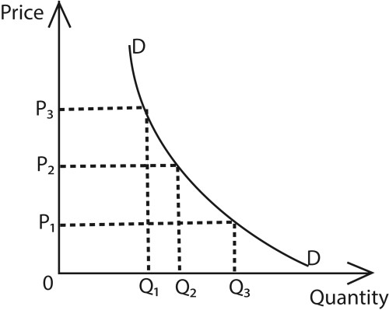
In this case, the price elasticity of demand equals to one. The percentage change in quantity demanded equals to the percentage change in price. It is illustrated by a rectangular hyperbola.

(iv) Elasticity of demand (1 < Ep < ꝏ)
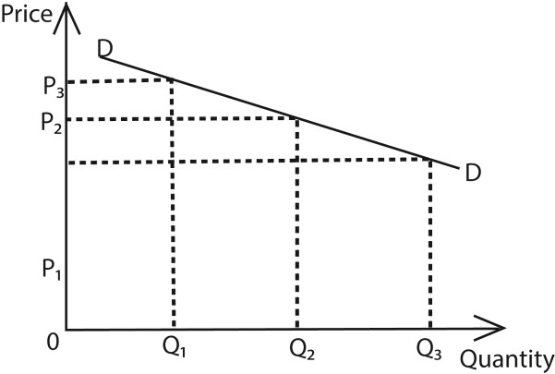
In this case, the price elasticity of demand is greater than one but less than infinity or is between one and infinity. A big percentage change in quantity demanded is due to a small percentage change in price

(v) Perfectly elastic demand (Ep = ꝏ)
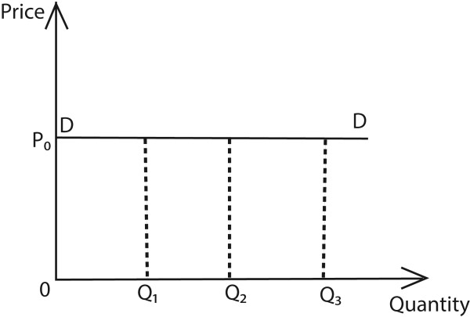

(b) Point elasticity of demand
This measures the elasticity of demand at a particular point on the demand curve. It is given by the formula

(c) Arc elasticity of demand
This is a measure of elasticity of demand between two points on the demand curve.
It is given by the formula
Given two points A and B along the same demand curve
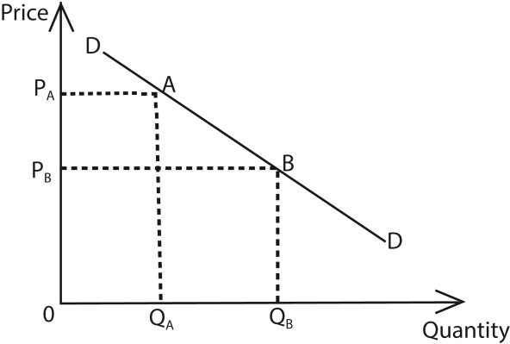
P(average) = 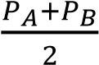; Q(average) = 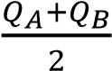

Example 3

Given the graph below
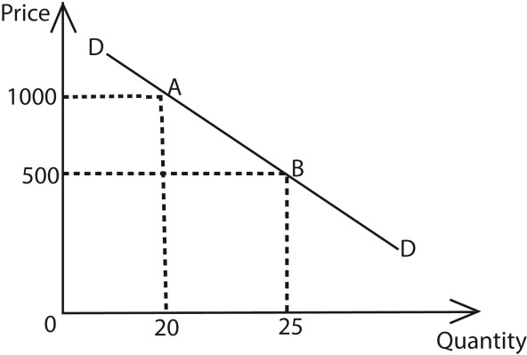

Calculate (i) Point elasticity of demand
ΔP = 500 – 1000 =-500 ΔQ = 25 – 20 = 5

Q_{A} = 20 Q_{B} = 25
(ii) Arc elasticity of demand

(d) Cross elasticity of demand
This is the measure of the degree of responsiveness of quantity demanded of commodity (Y) due to the changes in the price of a related commodity (X). It is given by the ration of the percentage change in the quantity demanded of commodity (Y) to the percentage change in price of related commodity (X).

Cross elasticity of demand (XED) =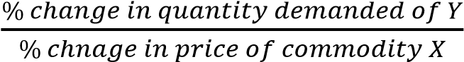 Interpretation of cross elasticity of demand
- If XED > 0 (positive): it implies that the commodities are substitute. An increase in the price of one of the commodity leads to an increase in to an increase in the quantity demanded of the other commodity. For example blue band and butter.
- If XED < 0 (negative): it means that the commodities are compliments. Increase in the price of one commodity leads to a decrease in the quantity demanded of the other commodity. For example a car and petrol.
- If XED = 0: it implies that the commodities are nonrelated. A change in price of one commodity has no effect on the quantity demanded of the other commodity.

Example 4
An increase in the quantity demanded of commodity X from 50 units to 80 units was due to the fall in price of commodity Y from 100/= to 150/=. (i) Calculate the cross elasticity of demand of commodity X and Y.
Percentage change in the commodity of X = 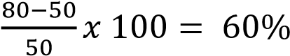
Percentage change in price of Y = 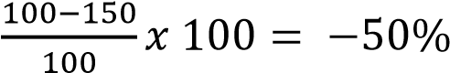
Cross elasticity of demand (XED) =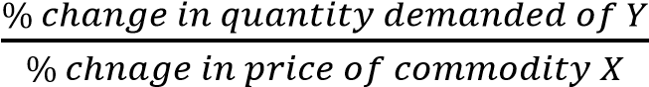
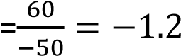
- State the nature of commodities X and Y The two commodities are complements
- Suggest two examples of X and Y
Camera and film; car and petrol, shoes and shoe polish

Example 5
A 30% increase in the quantity of commodity P is due to an increase in price of commodity Q from 200/= to 250/=
- Calculate the cross elasticity of demand of commodities P and Q
Percentage change in price of Q = 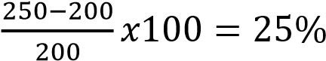
Cross elasticity of demand (XED) =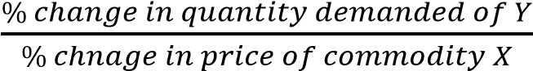
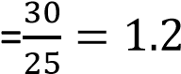
- State the nature of commodities P and Q The two commodities P and Q are substitute
- Give two examples of commodities P and Q
Kakira Sugar and Kinyara sugar, Samona baby jelly and Sleeping baby jelly, Omo and Nomi, Colgate tooth paste and Closeup tooth paste.

(e) Income elasticity of demand
Income elasticity of demand is the degree of responsiveness of demand of a commodity due to a change in Consumer’s income.
It is obtained as a ratio of the percentage change in the quantity demanded of a commodity to the percentage change in the customer’s income
Income elasticity of demand (YED) = 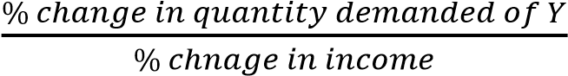

Interpretation of Income elasticity of demand
- If YED > 0 (positive): the commodity is a normal good. The demand for normal good increase as the consumer’s income increase.
- If YED < 0 (negative): the commodity is an inferior good. The demand for an inferior good reduces as the consumer’s income increases.
- If YED = 0: the commodity is a pure necessity. The increase in consumer’s income has no effect on the quantity demanded for a pure necessity such as salt.

Example 6
An increase in the consumer’s income from 1000/= to 1800/= led to an increase in the quantity demanded of commodity X from 20 to 30.
- Calculate the income elasticity of demand for commodity X.
Percentage change in income = 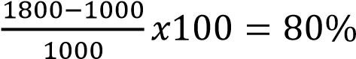
Percentage change in quantity of X demanded = 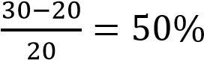
Income elasticity of demand (YED) = 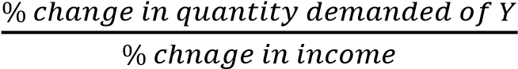
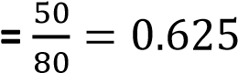
- What is the nature of commodity X Commodity X is normal good

Example 7
A 10% decrease in consumers income led to an increase in quantity demanded of commodity P from 25 to 32.
- Calculate the income elasticity of demand of commodity P
Percentage change in commodity P demanded = 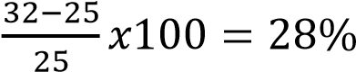
Income elasticity of demand (YED) = 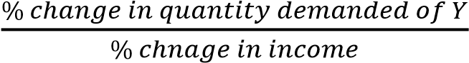
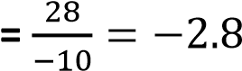
- State the nature of commodity P P is an inferior good

Example 8
Income | Quantity demanded of commodity P
250 | 50
600 | 25

- Calculate the income elasticity of demand of commodity P
Percentage change in income = 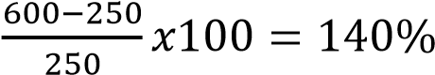
Percentage change in quantity of P = 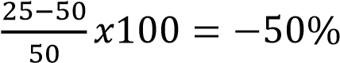
Income elasticity of demand (YED) = 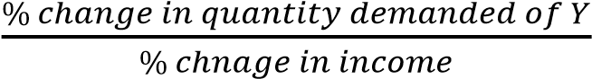
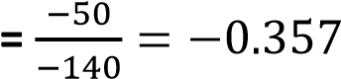

- What is the nature of commodity P P is an inferior good

Determinants of price elasticity of demand
- Availability of substitutes: The more close substitutes a product has, the more elastic its demand. For example, if the price of Pepsi rises, consumers can easily switch to Coca-Cola.
- Proportion of income spent: Goods that take up a large share of a consumer’s income (like cars or housing) tend to have more elastic demand, while inexpensive items (like salt) are less sensitive to price changes.
- Necessity vs luxury: Essential goods (like medicine) usually have inelastic demand, while luxury goods (like designer handbags) are more elastic.
- Time period considered: Demand is often more elastic in the long run because consumers have time to adjust their behavior, find substitutes, or change habits.
- Number of uses of a commodity: Goods with multiple uses (like electricity or steel) tend to have more elastic demand since a price change affects many applications.
- Complementarity between goods: If a product is strongly tied to another (like printers and ink cartridges), demand may be less elastic because consumers need both together.
- Brand loyalty: Strong loyalty reduces elasticity, as customers are less likely to switch even if prices rise.
- Information availability: When consumers are well-informed about alternatives and prices, demand becomes more elastic.
- Level of competition: Highly competitive markets increase elasticity since consumers can easily switch to rivals.
- Habit (addiction) in the consumption of the commodity. The demand for the commodity for which the consumer is addicted t o tends to be inelastic f o r example a consumer who is addicted to the consumption of cigarettes. On the other hand, the demand for the commodity for which the consumer i s not addicted to tends to be elastic
- Degree of durability of the commodity. The demand for a durable commodity tends to be inelastic. This is because even if the price of such a commodity falls, the consumer may not demand more of that commodity because he already has that commodity. On the other hand, the demand for a perishable commodity tends to be elastic.
- Level of advertisement for the commodity. The demand for a commodity that is highly advertised tends to be inelastic but the demand for the commodity that is not highly advertised tends to be elastic.
- Future price expectations. The demand for the commodity whose price is expected to decrease in future makes its current demand to be elastic but the demand for the commodity whose price is expected to increase in future makes its current demand to be inelastic.
- Degree of convenience in obtaining the commodity. The higher the level of convenience, the lower the elasticity of demand and the lower the level of convenience, the higher the elasticity of demand.

Practical application of price elasticity of demand to consumer
- Substitute choices: When the price of one product increases, consumers can switch to alternatives. For example, if beef becomes expensive, many households may buy chicken instead.
- Budget allocation: Consumers prioritize spending on goods with inelastic demand (like medicine or electricity) while cutting back on elastic goods (like entertainment or luxury items).
- Timing purchases: Elastic demand means consumers can wait for discounts or sales. For instance, shoppers often delay buying electronics until holiday promotions.
- Evaluating necessity vs luxury: Consumers recognize that necessities (like food staples) are less responsive to price changes, while luxuries (like designer clothes) can be postponed or avoided if prices rise.
- Awareness of tax impact: When governments impose taxes on goods with inelastic demand
(like fuel), consumers bear most of the burden since they cannot easily reduce consumption.
- Long-run adjustments: Over time, consumers adapt to price changes by finding substitutes, changing habits, or investing in alternatives (e.g., switching from gasoline cars to electric vehicles if fuel prices remain high).
- Information-driven decisions: With access to price comparisons online, consumers can respond more elastically by quickly finding cheaper substitutes.

Practical application of price elasticity of demand to Producers
- Pricing decisions: Producers use elasticity to decide whether raising or lowering prices will increase total revenue. If demand is elastic, lowering prices can boost sales volume and revenue; if inelastic, raising prices may increase revenue without losing many customers.
- Monopoly and market power: In monopolistic or less competitive markets, producers rely heavily on elasticity to determine the profit-maximizing price. A monopolist sets prices based on how sensitive consumers are to changes.
- Production planning: Elasticity guides producers in adjusting output. For goods with elastic demand, producers must be cautious about overproduction, while inelastic goods allow more stable production levels.
- Tax incidence and policy: Producers anticipate how taxes affect demand. If demand is inelastic (like fuel), producers can pass most of the tax burden to consumers. If demand is elastic, they may absorb part of the tax to maintain sales.
- Advertising and marketing: Firms invest in advertising to reduce elasticity by building brand loyalty. This makes demand less sensitive to price changes, allowing higher markups.
- Foreign trade decisions: Exporters consider elasticity when setting prices in international markets. If demand abroad is elastic, lowering prices can expand market share; if inelastic, higher prices may maximize profits.
- Product differentiation: Producers use elasticity insights to innovate and differentiate products, reducing substitutability and making demand more inelastic.
- It helps the producer in determining wages of his workers. Workers whose demand is inelastic are paid more than those whose demand is elastic
- Making decisions on what to produce. A businessman chooses the optimum product- mix on the basis of price elasticity of demand for various products. The products having more elastic demand are preferred by the businessmen. The sale of such products can be increased with a little reduction in their prices.

Practical application of price elasticity of demand to government
- Taxation policy: Governments impose higher taxes on goods with inelastic demand (like fuel, alcohol, and tobacco) because consumers cannot easily reduce consumption, ensuring stable tax revenue. For goods with elastic demand, heavy taxation may reduce consumption drastically, lowering revenue.
- Subsidy allocation: Subsidies are often directed toward goods with elastic demand (like public transport or renewable energy) to encourage greater consumption. For inelastic goods (like staple foods), subsidies help maintain affordability and protect vulnerable populations.
- Price controls and regulation: PED informs decisions on setting price ceilings (e.g., rent control, food staples) or price floors (e.g., minimum wage, agricultural products).
Governments avoid strict controls on highly elastic goods to prevent shortages or surpluses.
- Inflation management: By understanding elasticity, governments can predict how price changes in key sectors affect overall consumer spending and inflation.
- Public health policy: Taxes on cigarettes, alcohol, and sugary drinks (with relatively inelastic demand) serve dual purposes: raising revenue and discouraging harmful consumption.
- Trade and tariffs: PED helps governments assess the impact of tariffs on imports. If demand for imports is elastic, tariffs may reduce consumption sharply; if inelastic, tariffs generate revenue without major consumption changes.
- Environmental policy: Elasticity guides carbon taxes and green incentives. For example, taxing fossil fuels (inelastic demand) raises revenue, while subsidizing solar panels (elastic demand) encourages adoption.
- To reduce inflation. Government can levy taxes on products with inelastic demand to withdraw money from circulation
- Wage policy. This helps the government when establishing wages of its workers. Workers with inelastic demand such as Doctors are paid more than those that have elastic demand are paid less e.g. office messengers, cleaners, drivers
- It helps government in currency devaluation. The government can devalue its currency if her imports and exports have elastic demand and supply such that as the prices of imports increase, quantity of imports reduce and as prices of exports reduce the volume of export increase.

Elasticity of supply
Elasticity of supply refers to the degree of responsiveness of quantity supplied due to changes in the factors which influence supply
Price elasticity of supply is the measure of the degree of the responsiveness in quantity supplied due to changes in the price of commodity supplied
i.e. Price elasticity of supply (PES) = 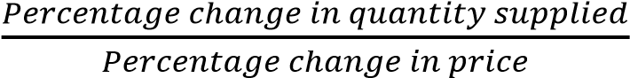

Example 6
An increase in the price of sugar from 100/= to 120/= per kilogram lead to an increase in the quantity supplied of sugar from 30kg to 40kg. Calculate the price elasticity of supply.
Solution
Percentage change in quantity =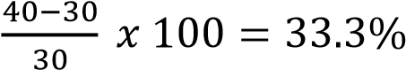
Percentage change in price = 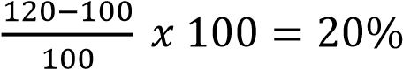
Price elasticity of supply (PES) = 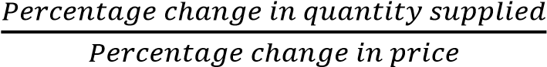
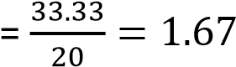

Example 7
An increase in the price of commodity by 40% causes an increase in quantity supplied of sugar from 200kg to 250kg. Calculate price elasticity of supply.
Solution
Percentage change in quantity = 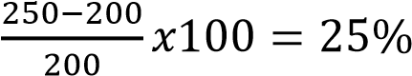
Price elasticity of supply (PES) = 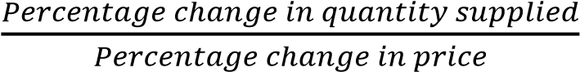
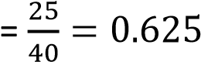
Interpretation of price elasticity of supply (a) Perfectly inelastic demand (E_{P}= 0).
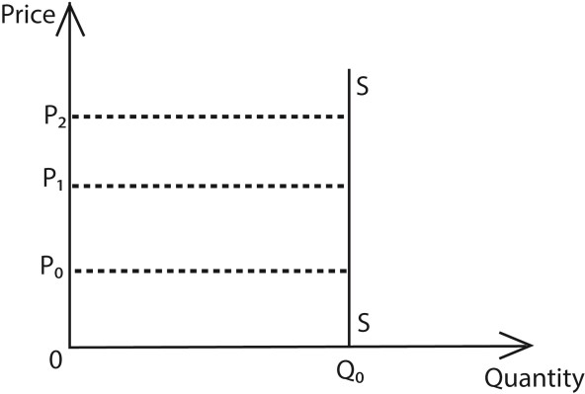

In this case, quantity supplied does not respond to changes in price. For example the supply of agricultural products in short runs.

(b) Inelastic demand (E_{P}= 0 < Ep < 1).

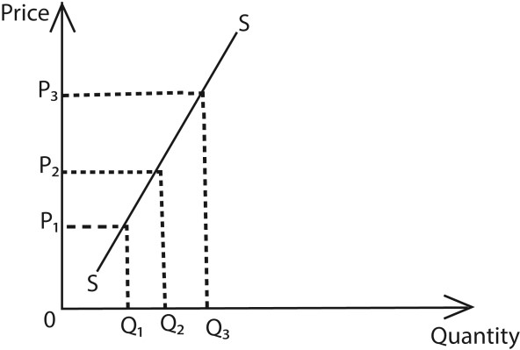
In this case, a big proportionate change in price leads to a small proportionate change in quantity supplied

(c) Unitary supply (Ep = 1)
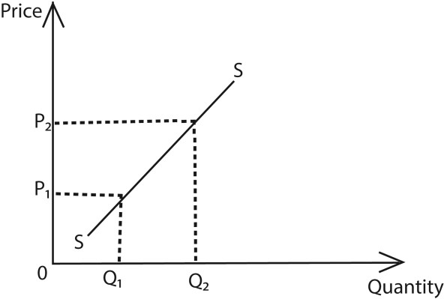

In this case, a percentage change in price leads to an equal percentage change in quantity supplied

(d) Elastic supply

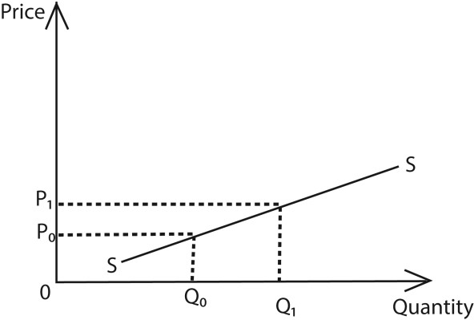
In this case, a small percentage change in price leads to a big percentage change in the quantity supplied.

(e) Perfectly elastic supply

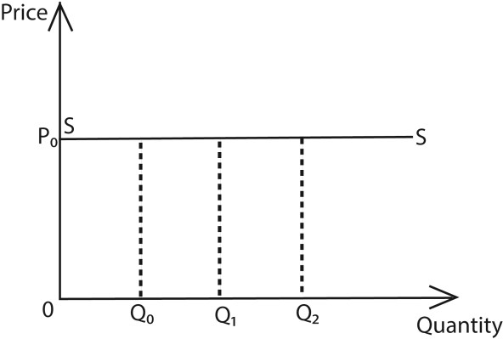
In this case, at constant price, quantity supplied increases. This situation is not applicable in the real world.

Determinants of Price Elasticity o f supply
- Availability of inputs: If raw materials and labor are easily accessible, producers can quickly increase output when prices rise, making supply more elastic. Scarce inputs reduce elasticity.
- Time period: Supply is usually more inelastic in the short run because firms cannot instantly adjust production. Over the long run, supply becomes more elastic as firms expand capacity or adopt new methods.
- Production capacity: Firms operating below full capacity can respond more easily to price changes, increasing elasticity. If they are already at maximum output, supply is less elastic.
- Storage possibilities: Goods that can be stored (like grains or manufactured products) have more elastic supply, since producers can release stock when prices rise. Perishable goods (like fresh fruits) are less elastic.
- Mobility of factors of production: If labor and capital can be shifted quickly between industries, supply is more elastic. Rigid or specialized resources reduce elasticity.
- Technological flexibility: Advanced technology allows producers to adjust production faster, increasing elasticity. Outdated or rigid technology makes supply less responsive
- Cost of production. The higher the cost of production, the more inelastic the supply of the commodity and the lower the cost of production; the higher the elasticity of supply.
- Gestation period (Length of the production process). The longer the gestation p e r i o d , t h e lower the elasticity o f supply and the shorter the gestation period, the higher the elasticity of supply.
- Degree of entry of firms in the production process. Free e n t r y of firms in the production process increases the number of producers of the product hence elastic supply while restricted entry of firms in the production process leads to inelastic supply e.g., the case of a monopolist.
- Government policy of taxation. High taxes imposed b y the government on producers increase the cost of production hence inelastic supply. However subsidization of producers by the government reduces the cost of production hence elastic supply.
- Price expectation. An expected future price f al l by the producer relative to the current prices makes the current supply of the commodity elastic. But the expected future price increase by the producer relative to the current prices makes the current supply inelastic.

Price discrimination
Price discrimination is a pricing strategy where a seller charges different price for the same product or service to different customers, based on their willingness or ability to pay for reasons not associated with costs. For example prices of entertainment tickets at different costs for public and students or children and adults.

Conditions necessary for price is discrimination succeed
- Market power: The firm must have some control over prices (not in perfect competition). Without market power, it cannot set different prices. Or The commodity should not have close substitute.
- Ability to segment markets: The seller must be able to distinguish between different groups of buyers (e.g., students, seniors, business travelers).
- Different elasticities of demand: Price discrimination works only if consumer groups respond differently to price changes. For example, business travelers (inelastic demand) pay more for flights than leisure travelers (elastic demand).
- No resale or arbitrage: Consumers who buy at a lower price must not be able to resell to those facing higher prices. Otherwise, the discrimination collapses.
- Information availability: The seller must know or estimate consumers’ willingness to pay to set differentiated prices.
- Legal and institutional allowance: Price discrimination must not be prohibited by law or regulation in the given market.
- Personal services that can be resold or transferred e.g. medical Doctor, teacher, entertainment etc.
- Product differentiation; artificial differences made on similar products by a way of branding, trademarks.

Engel curves
An Engel curve shows the relationship between a consumer’s income and the quantity of a good they purchase, holding prices constant. It illustrates how demand for a good changes as income changes

Angel curve for normal good
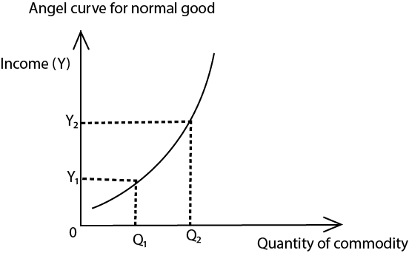
Quantity demanded for the commodity increases as household income increase
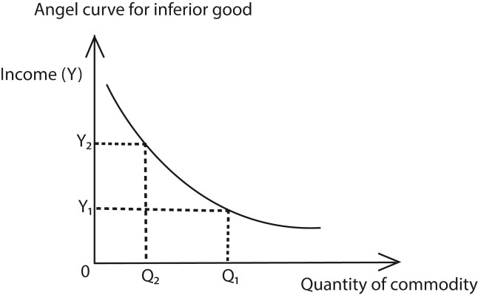
Quantity demanded for the commodity decreases as household income increase
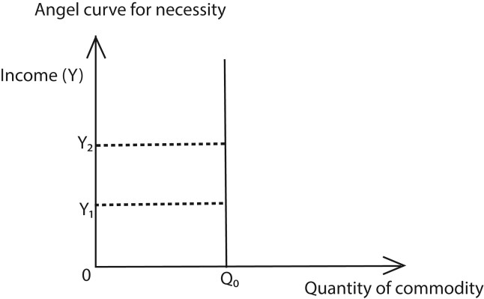
Quantity demanded for the commodity remains unchanged as household income change

Trial 1

Section A questions
1 (a) Distinguish between competitive demand and joint demand
(b) Give two examples o f competitive demand
2 (a) Distinguish between market price and equilibrium price
(b) Outline any two methods of price determination in an economy
3 (a) Distinguish between normal price and Reserve price
(b) State any two determinants of Reserve price
4 (a) what is meant by the angel curve
(b) Graphically illustrate the angel curves for normal, necessity a n d inferior g o o d s .
5 (a) Explain the concept of regressive d e m a n d c u r v e .
(b) Outline any three examples of regressive demand curves.
- Give four circumstances under which the demand for a commodity may not fall despite a rise in its price.
- With illustrations, explain the effects of a change in supply on the equilibrium price and quantity at constant demand of the commodity.
- Give any four circumstances under which a consumer may buy more of a commodity when its price increases.
- (a) What is meant by resale price maintenance
(b) Give any three advantages of resale price maintenance
- (a) What is meant by a regressive supply curve
  - Give any three reasons why the labour supply curve may be regressive
- An increase in income of the consumer from 10,000/= to 30,000/= led to a decrease in quantity demanded of commodity x from 50kgs to 20kgs.
  - Calculate the income elasticity of demand for commodity X
  - What type of commodity is X
- (a) Distinguish between income elasticity of demand and price elasticity of demand
  - An increase in the consumer’s income from 50,000/= to 60,000/= led to an increase in quantity demanded of commodity X by 10%. Calculate the income elasticity of demand for commodity X
- Given that the price of commodity Y decreased from 15,000/= to 10,000/= and the quantity demanded of a related commodity Z increased from 200,000kgs to 600,000kgs, calculate the cross elasticity of demand for commodity Z. State the consumption relationship between the two commodities
- (a) Distinguish between price elasticity of demand and cross elasticity of demand
  - Quantity demanded of commodity X increased by 50% due to a fall in commodity price by 25%. Determine the value and nature of price elasticity of demand for commodity X
- Calculate the cross elasticity of demand, if the price of the commodity A declined by 20% and quantity demanded of commodity B increased from 20 to 30units. How are commodities A and B related?
- Explain in details the following concepts;
  - Price elastic demand
  - Price inelastic demand
  - Price elasticity of supply
17. Use the table below to answer the questions that follow
Year | Income | Commodity X | Commodity Y | Commodity Z
2020 | 40000 | 100 | 60 | 200
2023 | 80000 | 100 | 30 | 2500

- Calculate the income elasticity of demand of each commodity from 2000 to 200 1.
- What type of goods are X, Y and Z.

- Study the table below and answer the questions that follow;
 | Position | Price | Quantity demanded
Original position | A | 40 | 400
New position | B | 80 | 150
  - What is the movement from A to B called?
  - Determine the value of price elasticity of demand for commodity
- Use graphs to illustrate;
  - an increase in supply at constant demand.
  - an increase in demand at constant demand.
- with the help of the graph distinguish between "Extension in demand" and" Contraction in demand"
- Given that quantity demanded is Q_{d} =36- 4P and quantity supplied is Q. =12+12P find the equilibrium price and quantity.

Section B questions
1 (a) How are prices determined in your country
(b) Examine the factors that influence quantity of a commodity demanded in an economy.
- (a) Distinguish between a contraction in demand and an extension in demand (b) Explain the factors that may lead to a decline in demand for a commodity.
- (a) Distinguish between change in supply and change in quantity supplied (Use graphs to illustrate)
(b) Explain the factors which influence the supply of commodities in your country.
- (a) Explain why demand curve slopes downwards from left to right
(b) Explain the circumstances under which the law of demand may be violated.
- (a) Explain the causes of high price elasticity of demand for commodities in an economy
(b) What are the practical applications of the concept of price elasticity of demand?
6 (a) Distinguish between a change in supply and change in quantity supplied
(b) Explain that factors that influence the elasticity of supply for the commodity in an economy
7 (a) Under what circumstances may the law of supply be violated
(b) Under what circumstances may the elasticity of demand for a commodity be price inelastic?
- (a) Distinguish between Arc elasticity of demand and point elasticity of demand ... (b) Explain the determinants of elasticity of demand for the commodity in an economy.
- (a) Explain why people tend to buy more of a commodity when its price falls. (b) What are the exceptions to tins phenomenon?

Consumers' surplus and producer’s surplus
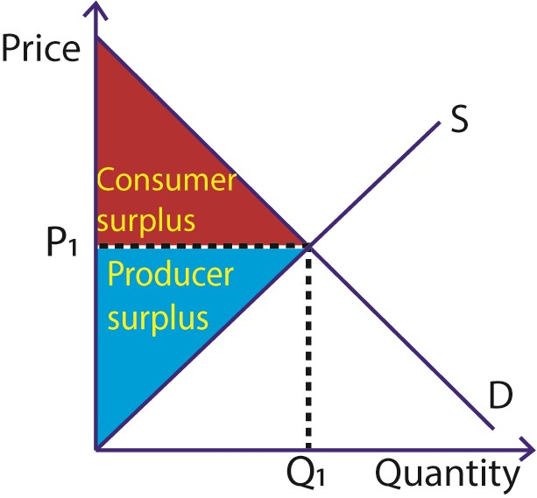

Consumers' Surplus
Consumer surplus is the difference between the maximum amount a consumer is willing and able to pay for a good or service and the actual amount they pay.
From the graph, consumer surplus is the shaded area below the demand curve and above the equilibrium price

Consumer surplus = total utility – actual expenditure

Example 8
Suppose a student is willing to pay UGX 10,000 for a textbook, but the market price is UGX 7,000.
The consumer surplus is: 10,000−7,000=3,000
That UGX 3,000 represents the extra satisfaction or benefit the student gains.

Producer surplus
Producer surplus is the difference between the amount a producer actually receives for selling a good and the minimum amount they would be willing to accept.
On a supply-and-demand diagram, producer surplus is the area above the supply curve and below the market price line, up to the quantity sold.

Producer Surplus=Market Price−Minimum Acceptable Price

Example 9
Suppose a farmer is willing to sell maize at UGX 1,000 per kg, but the market price is UGX 1,500 per kg.
For each kg sold, the producer surplus is: 1,500−1,000=500
If the farmer sells 100 kg, total producer surplus = UGX 50,000.

Transfer earning (supply price) and economic rent

Transfer earning (supply price) is the minimum reward (payment) given to a factor of production (like worker) in order to maintain its current employment (occupation) Or
Supply price is the opportunity cost of keeping a factor of production in its current occupation

For example, if a worker could earn Ug. shs.70,000 in a different job, their transfer earnings for their current job are Ug. shs70,000, regardless of their current salary.

Economic rent is the payment to a factor of production over and above its supply price Actual earnings = Transfer earning + economic rent
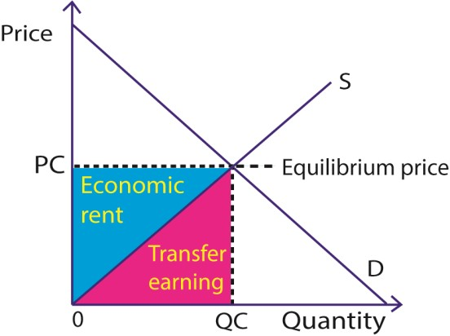

Example 10
Given that the transfer earnings for a factor of production is 3 times the economic rent and economic rent is 100/=.calculate the actual earnings for the factor of production.
Transfer earnings = 3 x 100 = 300/=
Actual earning = 300 + 100 = 400/=

Example 11
Given that the supply price of a worker is 5000/= and the actual payment is 7500/=. Calculate the level of economic rent.
Economic rent = actual payment – supply price
= 7500 – 5000 = 2500/=

Types of economic rent
- Quasi-Rent: A surplus earned by a factor of production whose supply is inelastic in the short run but elastic in long run,common in specialized machinery or skilled labor.
Example: A firm using a unique machine earns quasi-rent until competitors acquire similar technology.
- Scarcity Rent: Earned when the supply of a resource (like homogeneous land) is limited compared to its demand.
- Differential Rent: Arises due to differences in productivity or quality of resources.
Example: A farmer using highly productive land earns more than one using marginal land, even if both sell at the same market price.
- Situational Rent: Rent that arises because of a difference in the situation of land, such as proximity to markets.
- Entrepreneurial Rent: A surplus earned by entrepreneurs for their innovation and risktaking.
- Commercial rent. This refers to the hire price for a durable asset, for example rent paid for hiring a building.
- Monopoly Rent: Earned by firms or individuals who control a scarce resource or have exclusive rights. It results from market power, patents, or licenses.
Example: A telecom company with exclusive rights to operate in a region earns monopoly rent due to lack of competition.

Determinants of Economic rent
- Scarcity of the factor: When a resource (like fertile land or skilled labor) is limited in supply, it earns more than its transfer earning, creating economic rent.
- Productivity differences: More productive resources (e.g., high-yield land or efficient machines) generate higher output and earnings, leading to differential rent.
- Market power or exclusivity: Firms or individuals with monopolistic control, patents, or licenses can charge higher prices, resulting in monopoly rent.
- Mobility of the factor: If a factor is immobile or highly specialized, it cannot easily shift to other uses, increasing its economic rent.
- Time period: In the short run, some factors (like capital equipment) may earn quasi-rent due to temporary supply inelasticity.
- Government policies: Taxes, subsidies, and regulations can influence rent levels by affecting market conditions or resource allocation.

Price mechanism (invisible hand)
The price mechanism (invisible hand) is the process by which prices in a free market automatically adjust to balance supply and demand, guiding resources toward their most efficient use without central planning.

Assumptions of Price mechanism
- Consumers aim at utility maximization.
- There is no government interference (intervention) in resource allocation.
- Producers aim at profit maximization.
- There are many buyers and sellers of the same commodity
- It assumes that incomes are equally distributed and therefore individuals have the same purchasing power.

Understanding the Price Mechanism (Invisible Hand)
- Self-interest drives efficiency: Consumers seek the best deals, and producers seek profits.
Their actions unintentionally lead to efficient resource allocation.
- Price signals: Rising prices signal producers to increase supply, while falling prices signal them to reduce output.
- Market equilibrium: The interaction of supply and demand sets an equilibrium price where quantity demanded equals quantity supplied.
- Resource allocation: Resources flow to industries where demand (and profitability) is high, and away from less valued uses.
- Consumer sovereignty: Consumers, through their spending choices, dictate what producers make.
- No central control: The invisible hand works without government intervention, relying on decentralized decisions.

Example
- If bread is priced too high, fewer people buy it. Producers lower prices to attract buyers.
- If bread is priced too low, shortages occur, prompting producers to raise prices.
- Eventually, the market settles at a price where supply equals demand — the equilibrium.
Advantages (Merits) of Price mechanism .
- Efficient resource allocation: Prices guide resources to their most valued uses, minimizing waste and ensuring goods are produced where demand is strongest.
- Encourages competition: Producers compete to attract consumers, leading to better quality goods and services and innovation.
- Promotes consumer sovereignty: Consumers, through their spending choices, determine what is produced, ensuring markets reflect their preferences.
- Increases variety of goods and services: Producers respond to diverse consumer demands, creating more options in the market.
- Stimulates hard work and innovation: Firms and individuals strive to maximize profits, encouraging productivity and technological advancement.
- Supports economic growth: Efficient use of resources and competition expand production, leading to higher output and development.
- Creates employment opportunities: Profitable firms expand operations, generating jobs and improving living standards.
- Flexibility and adaptability: The mechanism quickly adjusts to changes in consumer preferences, technology, or resource availability.
- Price mechanism encourages speculation. Speculation refers to the buying of commodities in periods when they are in plenty and "cheap and selling them in periods when they are scarce and at high prices. This leads to price stability.
- It facilitates arbitrage. Arbitrage refers to me geographical transportation of commodities from areas where they are at low prices to areas where they are at high prices. This helps in redistribution of resources.
- It encourages flexibility in production as producers can easily adjust the production activities due to changes in price.
- It facilitates income distribution. This is because incomes go to those people who own resources and are able to buy goods and services.
- It encourages the development of entrepreneurial skills in the economy. This is because it promotes individual initiatives and creativity in the economy.

Disadvantages (Demerits) of Price mechanism
- Market failures: The price mechanism may fail to allocate resources efficiently in cases of externalities (like pollution) or public goods (like street lighting).
- Inequality: It can lead to unequal distribution of income and wealth, as those with higher purchasing power dominate demand.
- Neglect of social welfare: Essential services (like healthcare, education, or clean water) may be underprovided because they are not profitable.
- Instability: Free markets can cause price fluctuations, leading to inflation, unemployment, or economic crises.
- Monopoly power: Firms may exploit consumers by restricting supply and charging higher prices.
- Short-term focus: Producers may prioritize immediate profits over long-term sustainability, leading to overuse of resources.
- Regional imbalance: Resources may concentrate in profitable areas, leaving rural or less developed regions neglected.
- Consumer exploitation: Vulnerable groups may face high prices for necessities if demand is inelastic (e.g., food, medicine).
- It leads to fluctuation in incomes of sellers. Individuals selling umbrellas and rain coats, their incomes are high during the rainy season and Iow during the dry season which makes planning difficult.
- It promotes the production of socially harmful products. For example cocaine, marijuana, alcohol, cigarette if not restricted. This is because such commodities’ may be fetching high profits to the producers.

Ways of reducing the defects of price mechanism
- Government intervention: Through taxation, subsidies, and regulation, governments can correct market failures and ensure fairer outcomes.
- Provision of public goods: Since markets underprovide goods like roads, education, and healthcare, governments step in to supply them.
- Redistribution of income: Progressive taxation, social welfare programs, and minimum wage laws help reduce inequality caused by free markets.
- Control of monopolies: Antitrust laws and regulation prevent firms from exploiting consumers through monopoly power.
- Environmental regulation: Policies like pollution taxes or carbon caps address negative externalities that the price mechanism ignores.
- Price controls: Setting maximum or minimum prices (e.g., rent control, minimum wage) protects vulnerable groups from exploitation.
- Encouraging competition: Supporting small businesses and reducing entry barriers ensures markets remain dynamic and efficient.
- Social security measures: Programs like pensions, unemployment benefits, and healthcare reduce risks and protect citizens from market instability.
- Long-term planning: Governments invest in infrastructure, research, and education to balance the short-term focus of markets with sustainable growth.
- Forming consumers’ association to educate and sensitize the consumers about the quality of commodities brought in the market. This helps to reduce on consumers' ignorance.

Price c o n t r o l s (price administration)
Price controls (price administration) are government-imposed limits on the prices that can be charged for goods and services. They are used to protect consumers from excessively high prices or ensure producers receive fair returns, but they can also distort market outcomes. Types of Price Controls
- Price ceiling o Maximum price set below equilibrium.
o Protects consumers from high costs.
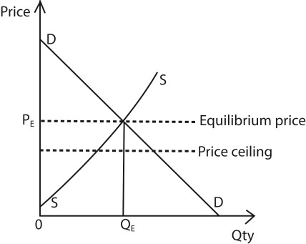
Example: Rent control, caps on essential medicines.
- Price floor o Minimum price set above equilibrium. o Protects producers from very low prices.
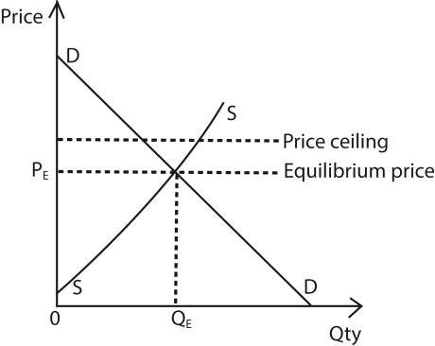
Example: Minimum wage laws, guaranteed prices for agricultural products.

Objectives of Price Administration
- Protect consumers from exploitation in essential goods (food, medicine, housing).
- Ensure fair income for producers, especially farmers and workers.
- Control inflation by preventing runaway prices.
- Stabilize markets during crises (wars, pandemics, shortages).
- Promote equity by making basic goods affordable for low-income groups.

Advantages of price administration
- Consumer protection: Prevents exploitation by ensuring essential goods (like food, medicine, housing) remain affordable.
- Market stability: Controls inflation and reduces extreme price fluctuations during shortages or crises.
- Fair income for producers: Price floors (like minimum wages or guaranteed crop prices) safeguard producers and workers from very low returns.
- Equity and social welfare: Helps low-income groups access basic necessities, reducing inequality.
- Encourages production of essentials: By guaranteeing minimum prices, farmers and producers are motivated to keep producing vital goods.
- Crisis management: During wars, pandemics, or natural disasters, price controls prevent hoarding and black-market exploitation.
- Employment security: Minimum wage laws ensure workers earn a fair livelihood, reducing poverty.
- Government revenue stability: By controlling inflation, governments can plan budgets more effectively.

Disadvantages of price administration
- Market distortions: Artificially fixing prices interferes with the natural balance of supply and demand.
- Shortages under price ceilings: When prices are set below equilibrium, demand exceeds supply, leading to scarcity of goods.
- Surpluses underprice floors: Minimum prices above equilibrium encourage excess supply, leaving unsold goods (e.g., agricultural products).
- Black markets: Shortages often lead to illegal trading at higher prices, undermining the purpose of controls.
- Reduced efficiency: Producers may lack incentives to cut costs or innovate since prices are fixed.
- Misallocation of resources: Resources may be diverted to less productive uses because prices no longer signal true scarcity.
- Administrative burden: Governments must spend heavily on monitoring and enforcement, which can be inefficient.
- Discourages investment: Producers may avoid industries with strict price controls, reducing long-term growth.

Example
- If the government sets a price ceiling on maize flour below market equilibrium, demand rises but supply falls, creating shortages.
- If it sets a price floor on coffee above equilibrium, farmers benefit but excess supply may remain unsold.

Price fluctuations (oscillations) of agricultural products

Price fluctuation r e f e r s to the variations i n the prices of products i n the economy o v e r time.

Causes of Price Fluctuations of Agricultural products
- Seasonal variations: Harvest seasons bring surplus supply and lower prices, while offseasons cause scarcity and higher prices.
- Production cost variations: Fluctuations in the cost of key inputs like energy (fuel for transport and farm machinery), fertilizers (whose prices are linked to natural gas prices), and labor can affect the final price of agricultural goods.
- Weather and climate conditions: Droughts, floods, or unpredictable rainfall affect yields, leading to sudden changes in supply and prices.
- Perishability of products: Since many agricultural goods (like fruits, vegetables, milk) cannot be stored for long, oversupply causes price drops while shortages push prices up.
- Demand changes: Shifts in consumer preferences, festivals, or population growth increase demand, raising prices.
- Inelastic demand for food: The overall demand for food is relatively constant because it is a basic necessity. Even large changes in price do not change the quantities demanded by very much. This means that a small change in supply can result in a disproportionately large change in price.
- Government policies: Price controls, subsidies, import/export restrictions, and taxation can directly influence agricultural prices.
- Transportation and storage costs: Poor infrastructure or high fuel costs raise the final market price of farm products.
- International trade: Global demand and supply (e.g., coffee, tea, maize exports) affect local prices through competition and exchange rates.
- Market intermediaries: Middlemen and traders may hoard products to create artificial scarcity, leading to price hikes.
- Technological changes: Adoption of modern farming methods increases supply, which can lower prices in the long run.
- Pests and diseases: Outbreaks reduce crop yields or livestock productivity, causing shortages and higher prices.
- Bulkiness of agricultural products. Agricultural products are bulky and this makes i t difficult t o transport t h e m from production areas to market areas. This leads to a fall in prices in production areas and an increase in prices in market areas.
- Competition from synthetic (artificial) fibers. Synthetic f i b e r s are cheap and are of high quality. Such fibers like nylon, silk etc. have led to low demand for agricultural products like cotton, sisal hence a decline in their prices in the world market.
- Cobweb theory. This theory explains price fluctuations of agricultural products. The high prices in the current period force the farmers to produce more of the commodity in the next season. This leads to excess supply hence a fall in prices. In the current periods of low prices, farmers are discouraged from producing more of a commodity in the next season hence an increase in prices.
- Geopolitical events: Wars, trade restrictions, and political instability can disrupt global supply chains and significantly impact the availability and prices of commodities like wheat and oil.
- Speculation and market sentiment: Traders and speculators in commodity exchanges buy and sell futures contracts to profit from price fluctuations, which can exacerbate shortterm volatility based on expectations and rumors, rather than just physical supply and demand dynamics.

Measures (ways) of reducing Price Fluctuations of agricultural products
Reducing price fluctuations ensures fair income for farmers, affordable food for consumers, and economic stability for the country. For example, in Uganda, stabilizing maize and coffee prices through storage, cooperatives, and export regulation has been a key policy focus.
- Improved storage facilities: Building silos, cold storage, and warehouses helps preserve surplus harvests for off-season use, stabilizing supply.
- Price stabilization schemes: Governments can set minimum support prices (MSPs) or guaranteed purchase programs to protect farmers from sharp price drops.
- Buffer stock policy: Maintaining reserves of essential crops allows governments to release stock during shortages and absorb excess during gluts.
- Crop diversification: Encouraging farmers to grow a mix of crops reduces dependence on one product, balancing supply and demand.
- Improved transport and infrastructure: Better roads and logistics reduce wastage and ensure timely delivery, preventing artificial scarcity.
- Market information systems: Providing farmers with real-time data on prices, demand, and weather helps them plan production and sales more effectively.
- Export-import regulation: Adjusting trade policies (e.g., restricting exports during shortages or allowing imports during deficits) stabilizes domestic prices.
- Insurance schemes: Crop and weather insurance protect farmers against losses, reducing panic selling and stabilizing supply.
- Technological improvements: Modern farming techniques, irrigation, and pest control reduce yield variability, ensuring more stable supply.
- Cooperative marketing: Farmer cooperatives can pool resources, negotiate better prices, and reduce exploitation by middlemen.
- Forming international commodity agreements. These help to fix prices and quotas for the buyers and sellers of commodities to avoid fluctuations of prices in the world market resulting from excess supply.
- Industrialization (processing) of agricultural products. Agro-based industries should be emphasized so as to add value on the agricultural products. This helps to improve on the quality and prices of agricultural products.
- Use of stabilization fund. This is where marketing boards (government) fix prices given to farmers. When there is a fall in supply, marketing boards sell the commodity at a high price on the world market than that paid to the farmers. During periods of plenty, the high profits made by marketing boards .are used to compensate fanners for the low prices as a way of stabilizing prices of agriculture products.

Effects of price fluctuations of agricultural products
- On farmers’ income: Sudden drops in prices reduce farmers’ earnings, discouraging production and investment. Sharp rises may benefit farmers temporarily but can be unstable in the long run.
- On consumers: High prices make food unaffordable, especially for low-income households. Low prices may benefit consumers but can reduce product quality if farmers cut costs.
- On food security: unstable prices lead to uncertainty in supply, risking shortages of essential staples.
- On government policy: Frequent fluctuations force governments to intervene with subsidies, price controls, or imports, straining budgets.
- On investment in agriculture: Price instability discourages farmers and agribusinesses from investing in modern technology or expanding production.
- On rural development: Farmers’ reduced income during price crashes slows rural economic growth and increases poverty.
- On inflation: Rising food prices contribute to overall inflation, affecting the cost of living and wage demands.
- On international trade: Export crops like coffee, tea, or maize face unstable earnings, making foreign exchange revenues unpredictable.
- Difficulty in planning by the government. With price fluctuations, it becomes very difficult for the government to plan as the expected revenue, is highly uncertain. The fluctuations in prices lead to fluctuations in incomes of farmers and hence fluctuations in the tax revenue for government.
- Fluctuation in the levels of employment especially in the agricultural sector. This is because the low prices-discourage producers and this leads to a reduction in output and in. the process workers remain under or unemployed.
- Unfavorable terms of trade. Terms of trade refers to the ratio of the price index of exports to price index of imports. When the prices for imports exceed the price for exports, the country is said to experience unfavorable terms of trade.
- They encourage rural-urban migration. Price fluctuations lead to rural-urban migration as farmers abandon agriculture and move to towns in search for white collars jobs which are highly paying. In addition other farmers move to towns to carryout business where the prices are relatively stable and the profits relatively high.

Consumer behavior
Consumer behavior refers to the study of how individuals, groups, or organizations make decisions about purchasing, using, and disposing of goods and services. It examines the psychological, social, cultural, and economic factors that influence buying choices.

Theories of Consumer Behavior

Cardinal Utility Theory (Marshallian Utility Analysis)
Definition: Cardinal utility theory (developed by Alfred Marshall and other classical economists) assumes that the satisfaction (utility) a consumer derives from goods and services can be measured in absolute units called utils.
Core Idea: Consumers make choices to maximize total utility, and utility can be quantified numerically (e.g., 10 utils from an apple, 20 utils from a banana).

Definitions of concepts

Utility refers to the satisfaction derived from consuming a given commodity. The expected utility from the commodity forms the basis for consumer demand. Hence consumers demand a commodity because they expect to derive utility from it.

Total Utility refers to the total satisfaction derived from consuming a given commodity. It is measured utils using an instrument called utilometer.

Marginal utility refers to the additional satisfaction derived from consuming an extra unit of a commodity.
Disutility (negative utility) is the dis-satisfaction resulting from consuming a commodity in excess.

Assumptions of Cardinal Utility Theory
- Measurability of utility: Utility can be expressed in cardinal numbers (e.g., 1, 2, 3 utils).
- Rational consumer: Consumers aim to maximize satisfaction given their income and prices.
- Constant marginal utility of money: The utility of money remains unchanged regardless of how much is spent.
- Independent utilities: Utility from one good is independent of utility from another.
- The consumer has perfect knowledge about the prevailing market prices and quality of the product.
- The consumer's tastes and preferences are constant.
- It assumes consumption of only one commodity whose units are homogenous.
- There is perfect divisibility of the commodities consumed into smaller units
- Diminishing marginal utility: Each additional unit of a good provides less satisfaction than the previous one.

Law of Diminishing Marginal Utility
States that as a consumer consumes more units of a good, the extra satisfaction (marginal utility) decreases.
Example: The first slice of pizza gives high satisfaction, the second gives less, and by the fourth or fifth slice, satisfaction may decline sharply.

Applications (Importance) of the law of diminishing marginal utility
- Basis of the downward-sloping demand curve: DMU explains why consumers buy more only at lower prices. As utility falls with each unit, willingness to pay decreases.
- Foundation of consumer demand theory: Helps economists understand how consumers allocate income to maximize satisfaction.
- Pricing of goods and services: Businesses set lower prices for additional units (bulk discounts, buy-one-get-one offers) because marginal utility declines.
- Taxation policy: Supports progressive taxation: the utility of money decreases as income rises, so taxing the rich more causes less sacrifice compared to taxing the poor.
- Value of money: Explains why each additional unit of currency provides less satisfaction, influencing savings and spending behavior.
- Consumer equilibrium analysis: DMU is used to determine how consumers distribute expenditure across goods to maximize total utility.
- Welfare economics: Justifies redistribution of wealth, since transferring money from rich to poor increases overall social welfare (poor derive higher utility from each unit of money).
- Pricing of public utilities: Governments often subsidize essential goods (water, electricity) because marginal utility is high for initial units consumed.
- Business strategies: Firms use DMU to design marketing tactics like product bundling, free samples, and loyalty rewards.

Limitations (criticisms) of the law of diminishing marginal utility
- Utility is subjective: Satisfaction cannot be measured precisely in numbers (utils), making the law more theoretical than practical.
- Assumes rational behavior: Consumers don’t always act rationally; emotions, habits, and social influences often drive purchases.
- Constant utility of money assumption: The law assumes the marginal utility of money remains constant, but in reality, it changes with income and circumstances.
- Independent utility assumption: It ignores the interdependence of goods (e.g., tea and sugar consumed together). Utility from one product often depends on another.
- Not applicable to indivisible goods: The law works best for divisible goods (like food items). For indivisible goods (like cars or houses), utility doesn’t diminish in the same way.
- Difficult to isolate utility: In real life, it’s hard to separate the utility of one unit from another, especially for services or experiences.
- Exceptions exist: Some goods (like collectibles, art, or addictive substances) may show increasing utility with more consumption, contradicting the law.
- Static analysis: The law assumes conditions remain unchanged during consumption, but in reality, tastes, preferences, and external factors evolve.
- It is not applicable i n situations where the commodity prices keep on changing due to inflation.
- It is not applicable under habitual consumption where marginal utility increases as the consumer consumes more of the commodity.
- In most cases the consumers are ignorant about the market prices of commodities. This violates the assumption of perfect knowledge of the consumer about the market price.

Importance of Cardinal Utility Theory
Despite its limitations, Cardinal Utility Theory laid the foundation for modern microeconomics, introducing concepts like marginal utility and consumer equilibrium.
- Foundation of demand theory: It explains why the demand curve slopes downward: as marginal utility diminishes, consumers only buy more at lower prices.
- Introduction of marginal utility concept: The theory gave economists the tool of marginal utility, which remains central in microeconomics today.
- Consumer equilibrium analysis: It provides a framework for understanding how consumers allocate income across goods to maximize satisfaction.
- Basis for the law of demand: The law of diminishing marginal utility directly supports the law of demand, linking psychology with market behavior.
- Pricing and value determination: Helps explain how consumers decide what they are willing to pay for goods and services.
- Taxation and welfare economics: Justifies progressive taxation: since the utility of money diminishes, taxing the rich more causes less sacrifice than taxing the poor.
- Foundation for later theories: Though replaced by ordinal utility and indifference curve analysis, cardinal utility laid the groundwork for modern consumer theory.

Trial 2

Section A questions

1 Mention f o u r assumptions on which price mechanism is based
2· (a) Distinguish b e t w e e n price legislation and price leadership
(b) State any two objectives o f price legislation in an economy 3 (a) Define the term price?
(b) Outline any three uses of price.
- (a) what is a black market?
(b) Give two reasons why a black market may occur.
- (a) What is meant by consumer's surplus
(b) Give the demand schedule
Price | 500 | 450 | 400 | 350 | 300 | 250
Quantity | 1 | 3 | 5 | 7 | 9 | 11

If the equilibrium price is 350/= calculate the consumer's surplus
- (a) Distinguish between Transfer e a r n i n g s and economic rent
(b) State any two factors which influence t h e level of economic rent.
- (a) Distinguish between Quasi Rent and commercial rent
(b) Given that the Transfer earnings for the factor of production is 200,000 and the economic rent is two thirds of the Transfer earnings. Calculate the actual earnings for the factor of production
- Explain the meaning of the following terms; (a) Marginal Utility of income.
  - Marginal rate of substitution.
- (a) A given factor of production earns 500,000/= as its transfer earnings. If it's actual earnings are thrice it's transfer earnings, calculate it's economic rent (b) How is elasticity of supply related to a factor's economic rent?
- (a) State the law of diminishing marginal utility.
  - Mention any three limitations of the law of diminishing marginal utility.
  - How is diminishing marginal utility related to demand curve and price?
- Mention four short comings of price fluctuations of primary products in an economy.
- State the properties of a normal indifference curve. .

Section B questions
- (a) What is meant by price mechanism.
  - Examine the advantages and disadvantages of price mechanism
- (a) Explain the role of the price mechanism in allocating resources in the economy
  - Explain the circumstances under which price mechanism may fail to allocate resources efficiently.
- (a) Distinguish between maximum price legislation and minimum price legislation (b) Examine the merits and demerits of fixing a maximum price.
4. (a) Distinguish between price control and price support.
- Assess the consequences of price legislation in an economy 5 (a) Account for price fluctuations of agricultural products in your country (b) What are the effects of such price fluctuations in your country?
- How may government stabilize prices of agricultural products in your country?
6. (a) Explain the reasons for setting maximum price in an economy (b) What are the negative effects of fixing a minimum price in an economy?
- (a) Why are prices of manufactured goods more stable than prices of primary products in your country?
  - Account for the need to stabilize prices of agricultural products in your country.
- (a) Discuss the assumptions and limitations of using the cardinal utility theory in explaining consumer behaviour
  - With the use of a clear diagram, explain how the demand curve for a normal good is derived under the cardinal utility approach

